IDSProject

2023-12-01

## R Markdown

#EDA

## Warning: package 'arrow' was built under R version 4.3.2

##   
## Attaching package: 'arrow'

## The following object is masked from 'package:utils':  
##   
## timestamp

## ── Attaching core tidyverse packages ──────────────────────── tidyverse 2.0.0 ──  
## ✔ dplyr 1.1.2 ✔ readr 2.1.4  
## ✔ forcats 1.0.0 ✔ stringr 1.5.0  
## ✔ ggplot2 3.4.3 ✔ tibble 3.2.1  
## ✔ lubridate 1.9.2 ✔ tidyr 1.3.0  
## ✔ purrr 1.0.2   
## ── Conflicts ────────────────────────────────────────── tidyverse_conflicts() ──  
## ✖ lubridate::duration() masks arrow::duration()  
## ✖ dplyr::filter() masks stats::filter()  
## ✖ dplyr::lag() masks stats::lag()  
## ℹ Use the conflicted package (<http://conflicted.r-lib.org/>) to force all conflicts to become errors

data <- read_csv("C:/Users/Himanshu/OneDrive/Desktop/Syracuse Sem 1/IST-687 Intro to DS Lab/Final Project/static_house_energy_weather_df_17130_rows_with_time_of_day.csv", show_col_types = FALSE)  
#summary(data)  
View(data)  
  
cols_req = c('bldg_id', 'in.sqft', 'in.bedrooms', 'in.building_america_climate_zone', 'in.ceiling_fan','in.census_region', 'in.city', 'in.clothes_dryer', 'in.clothes_washer', 'in.clothes_washer_presence', 'in.cooking_range', 'in.cooling_setpoint', 'in.cooling_setpoint_has_offset', 'in.cooling_setpoint_offset_magnitude', 'in.cooling_setpoint_offset_period', 'in.dishwasher', 'in.ducts', 'in.emissions_fuel_oil_values', 'in.emissions_natural_gas_values', 'in.emissions_propane_values', 'in.emissions_wood_values', 'in.federal_poverty_level', 'in.geometry_attic_type', 'in.geometry_floor_area', 'in.geometry_floor_area_bin', 'in.geometry_foundation_type', 'in.geometry_garage', 'in.geometry_stories', 'in.geometry_wall_exterior_finish', 'in.geometry_wall_type', 'in.has_pv', 'in.heating_fuel', 'in.heating_setpoint', 'in.heating_setpoint_has_offset', 'in.heating_setpoint_offset_magnitude', 'in.heating_setpoint_offset_period', 'in.hot_water_fixtures', 'in.hvac_cooling_efficiency', 'in.hvac_cooling_partial_space_conditioning', 'in.hvac_cooling_type', 'in.hvac_has_ducts', 'in.hvac_has_zonal_electric_heating', 'in.hvac_heating_efficiency', 'in.hvac_heating_type', 'in.hvac_heating_type_and_fuel', 'in.income', 'in.infiltration', 'in.insulation_ceiling', 'in.insulation_floor', 'in.insulation_foundation_wall', 'in.insulation_rim_joist', 'in.insulation_roof', 'in.insulation_slab', 'in.insulation_wall', 'in.interior_shading', 'in.misc_extra_refrigerator', 'in.misc_freezer', 'in.misc_gas_fireplace', 'in.misc_gas_grill', 'in.misc_gas_lighting', 'in.misc_hot_tub_spa', 'in.misc_pool', 'in.misc_pool_heater', 'in.misc_pool_pump', 'in.misc_well_pump', 'in.natural_ventilation', 'in.neighbors', 'in.occupants', 'in.orientation', 'in.plug_load_diversity', 'in.pv_orientation', 'in.pv_system_size', 'in.refrigerator', 'in.roof_material', 'in.tenure', 'in.units_represented', 'in.usage_level', 'in.vacancy_status', 'in.vintage', 'in.vintage_acs', 'in.water_heater_efficiency', 'in.water_heater_fuel', 'in.window_areas', 'in.windows', 'upgrade.insulation_roof', 'upgrade.water_heater_efficiency', 'upgrade.hvac_cooling_efficiency', 'upgrade.infiltration_reduction', 'upgrade.geometry_foundation_type', 'upgrade.clothes_dryer', 'upgrade.insulation_ceiling', 'upgrade.ducts', 'upgrade.hvac_heating_type', 'upgrade.insulation_wall', 'upgrade.insulation_foundation_wall', 'upgrade.hvac_heating_efficiency', 'upgrade.cooking_range', 'time_of_day', 'total_energy_consumption', 'dry_bulb_temperature_[°c]', 'relative_humidity_[%]', 'wind_speed_[m/s]', 'wind_direction_[deg]', 'global_horizontal_radiation_[w/m2]', 'direct_normal_radiation_[w/m2]', 'diffuse_horizontal_radiation_[w/m2]')  
  
filtered_data <- select(data, all_of(cols_req))  
  
#summary(filtered_data)  
  
columns_to_remove <- c("in.units_represented")  
filtered_data <- filtered_data[, !names(filtered_data) %in% columns_to_remove]

# Assuming filtered_data is your dataframe  
  
# Select string columns  
string_columns <- names(filtered_data)[sapply(filtered_data, is.character)]  
num_columns <- names(filtered_data)[sapply(filtered_data, is.numeric)]  
  
# Loop through each string column  
for (col in string_columns) {  
 p_c <- (which(string_columns == col)) / length(string_columns) * 100  
 print(paste(col, p_c, '%'))  
   
 # Plotting mean of total_energy_consumption per group  
 aggregate(filtered_data$total_energy_consumption ~ filtered_data[[col]], data = filtered_data, FUN = mean) -> temp  
 barplot(temp[, 2], names.arg = temp[, 1], main = paste('Bar Plot: Mean of total_energy_consumption per', col), xlab = col, ylab = 'Sum of total_energy_consumption', col = 'skyblue')  
   
 # Plotting count per group  
 table(filtered_data[[col]]) -> count_data  
 barplot(count_data, main = paste('Count per', col), xlab = col, ylab = 'Count', col = 'skyblue')  
}

## [1] "in.building_america_climate_zone 1.0989010989011 %"

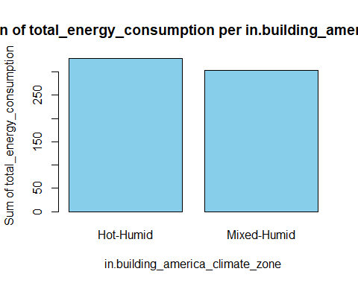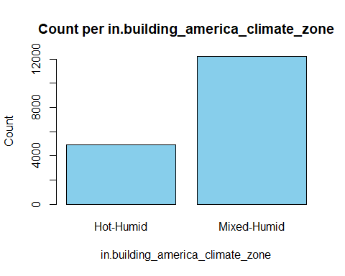

## [1] "in.ceiling_fan 2.1978021978022 %"

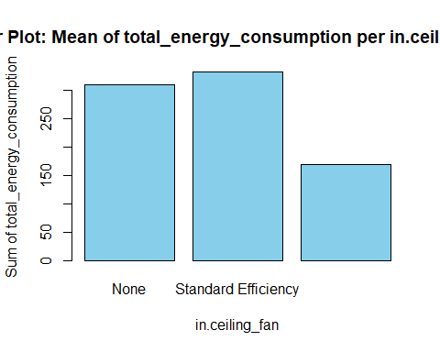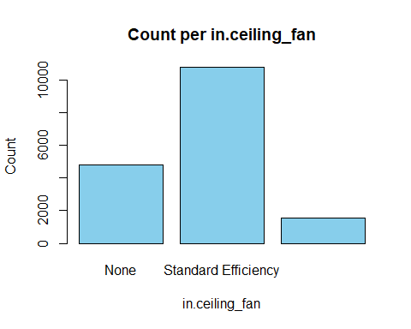

## [1] "in.census_region 3.2967032967033 %"

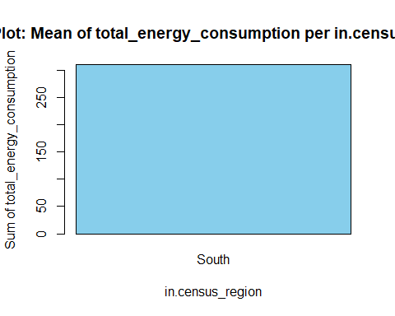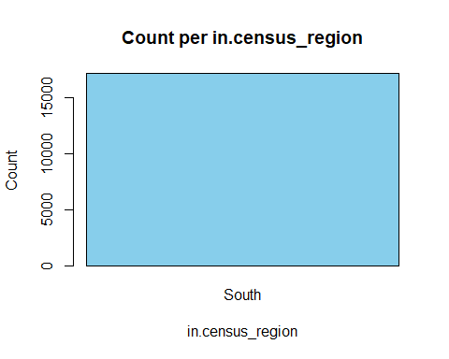

## [1] "in.city 4.3956043956044 %"

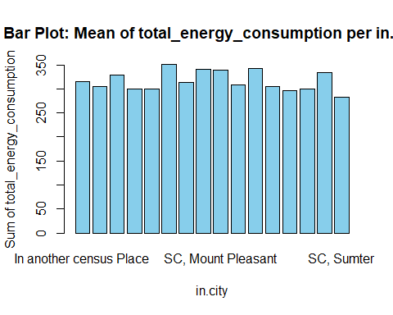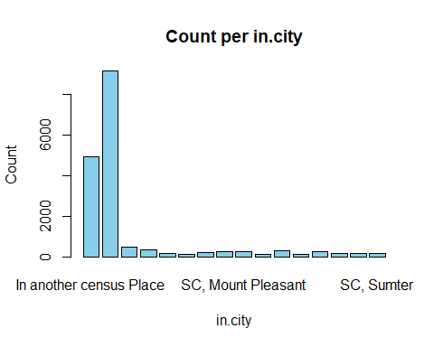

## [1] "in.clothes_dryer 5.49450549450549 %"

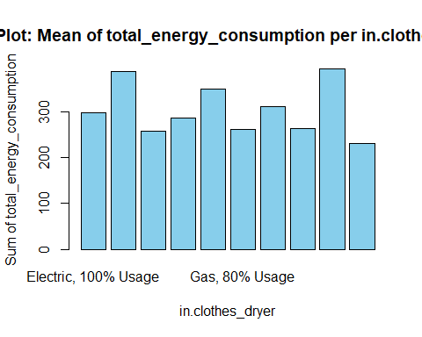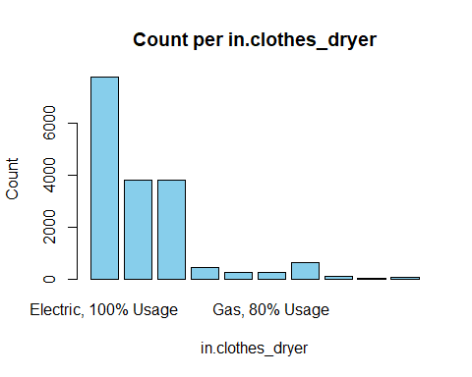

## [1] "in.clothes_washer 6.59340659340659 %"

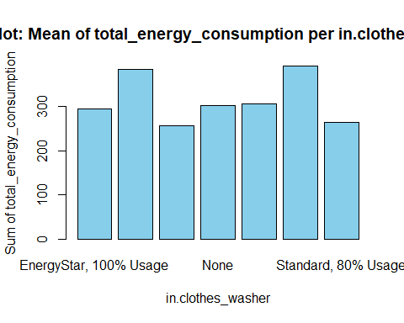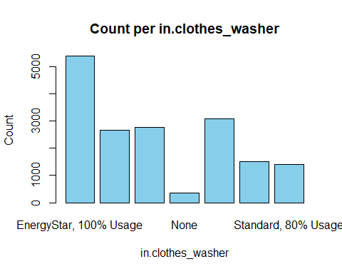

## [1] "in.clothes_washer_presence 7.69230769230769 %"

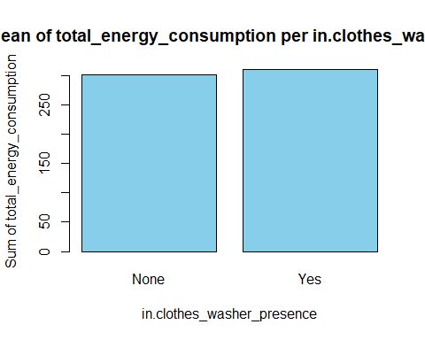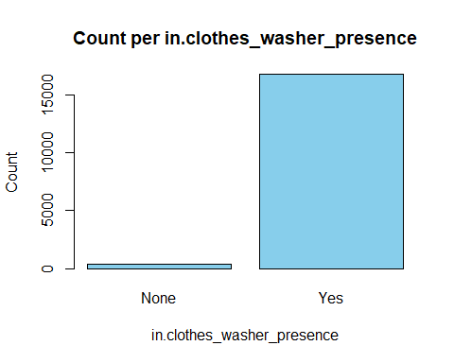

## [1] "in.cooking_range 8.79120879120879 %"

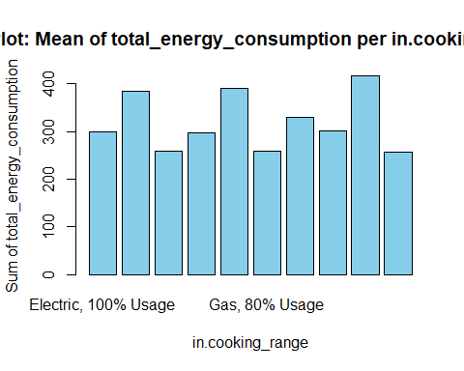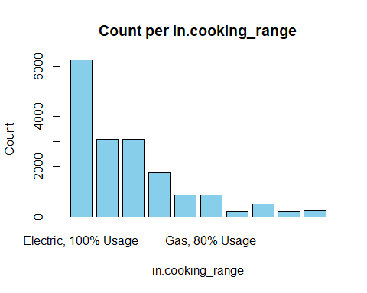

## [1] "in.cooling_setpoint_has_offset 9.89010989010989 %"

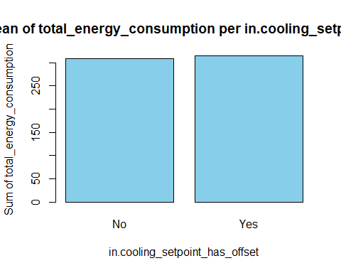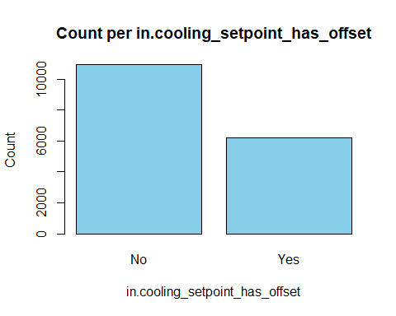

## [1] "in.cooling_setpoint_offset_magnitude 10.989010989011 %"

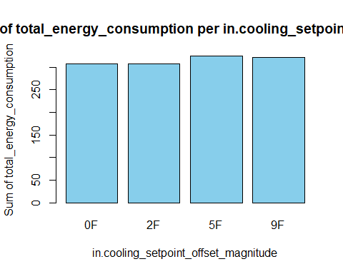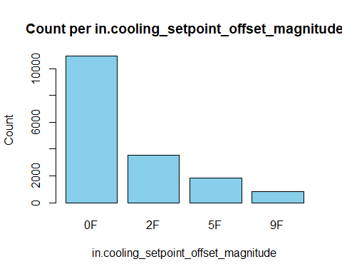

## [1] "in.cooling_setpoint_offset_period 12.0879120879121 %"

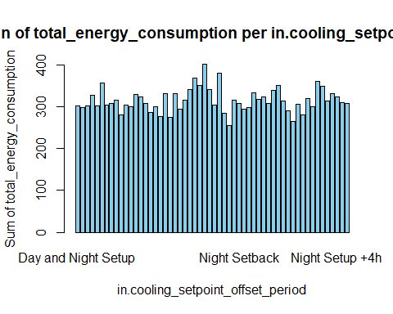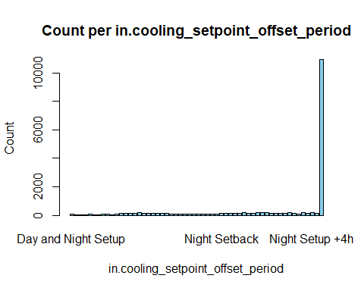

## [1] "in.dishwasher 13.1868131868132 %"

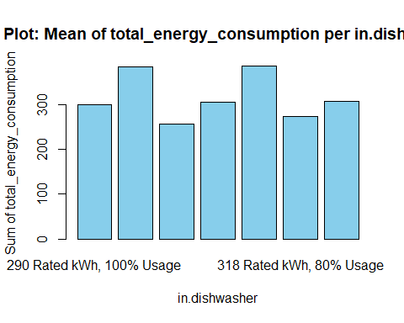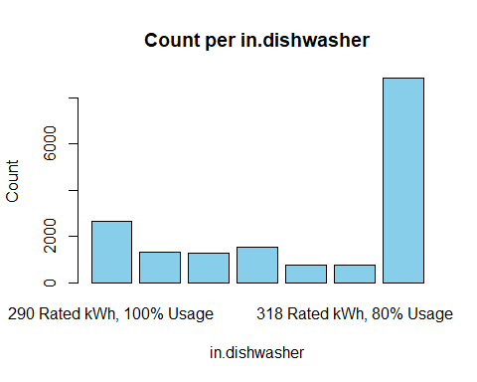

## [1] "in.ducts 14.2857142857143 %"

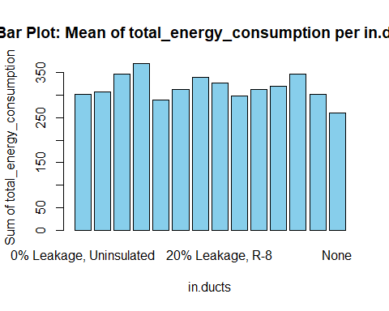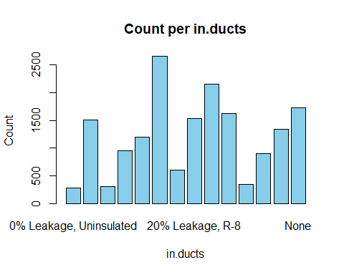

## [1] "in.emissions_fuel_oil_values 15.3846153846154 %"

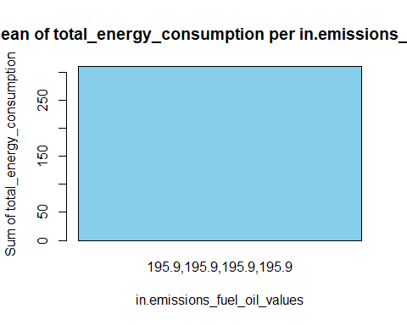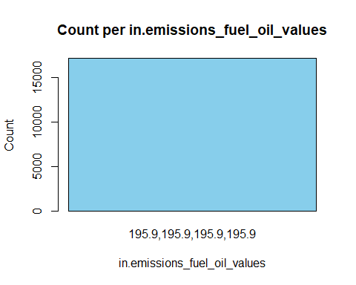

## [1] "in.emissions_natural_gas_values 16.4835164835165 %"

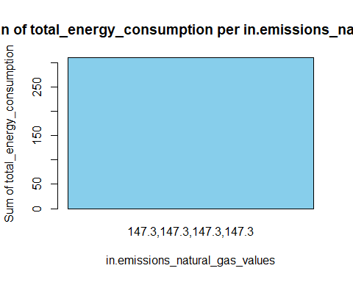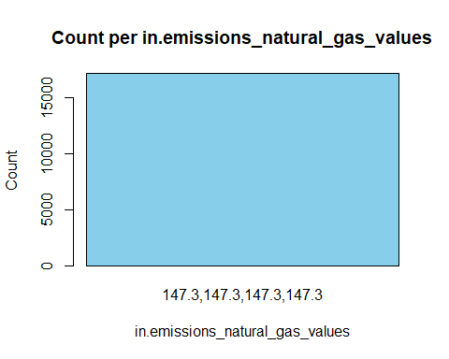

## [1] "in.emissions_propane_values 17.5824175824176 %"

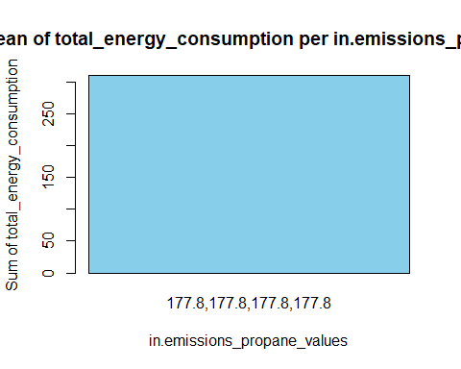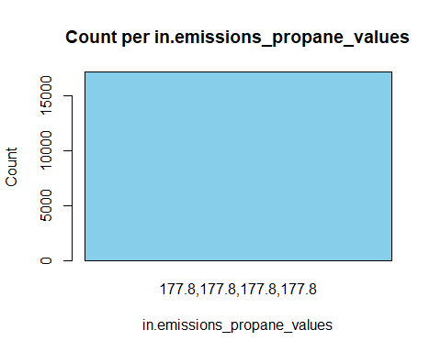

## [1] "in.emissions_wood_values 18.6813186813187 %"

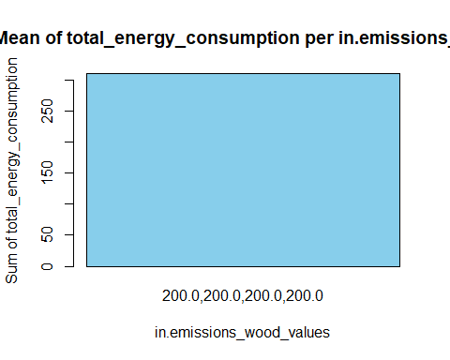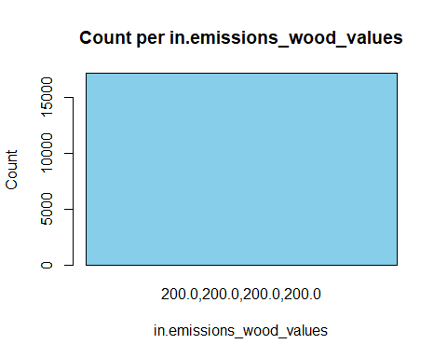

## [1] "in.federal_poverty_level 19.7802197802198 %"

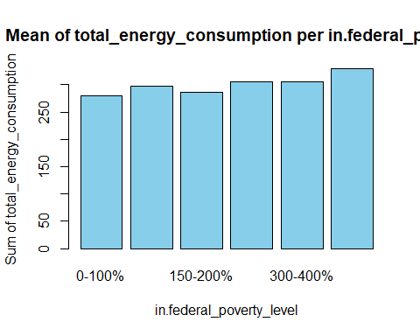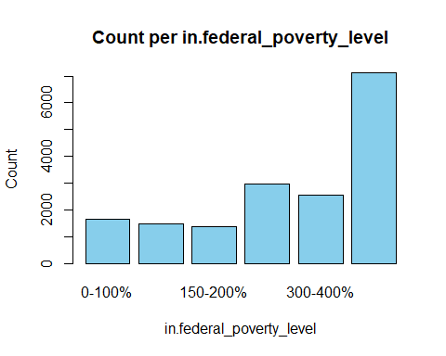

## [1] "in.geometry_attic_type 20.8791208791209 %"

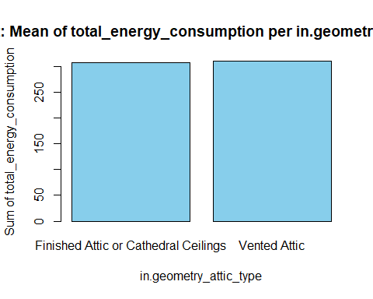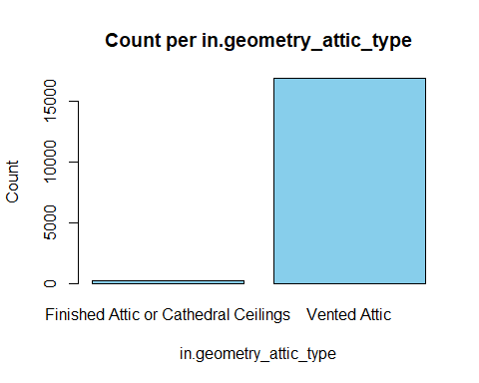

## [1] "in.geometry_floor_area 21.978021978022 %"

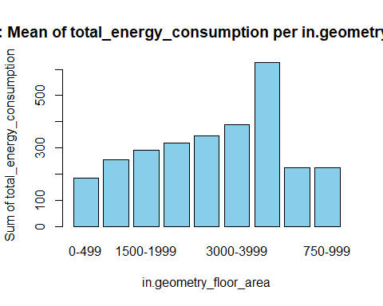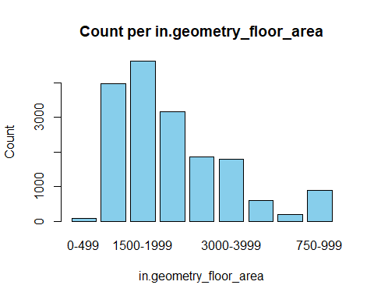

## [1] "in.geometry_floor_area_bin 23.0769230769231 %"

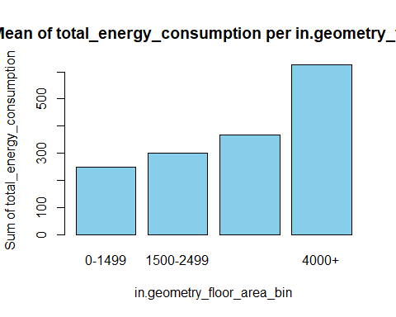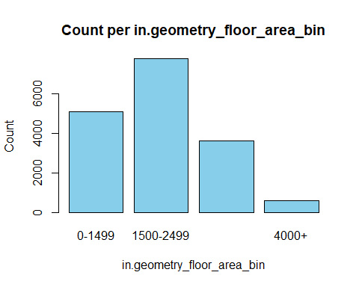

## [1] "in.geometry_foundation_type 24.1758241758242 %"

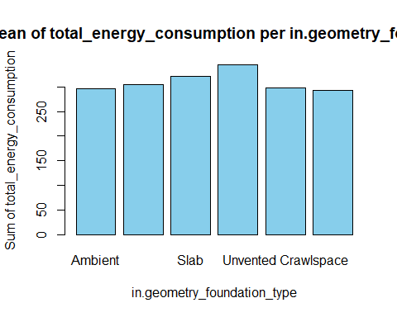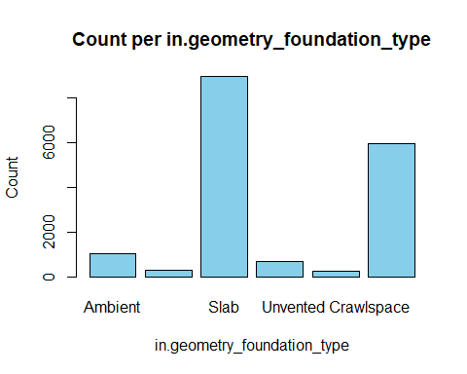

## [1] "in.geometry_garage 25.2747252747253 %"

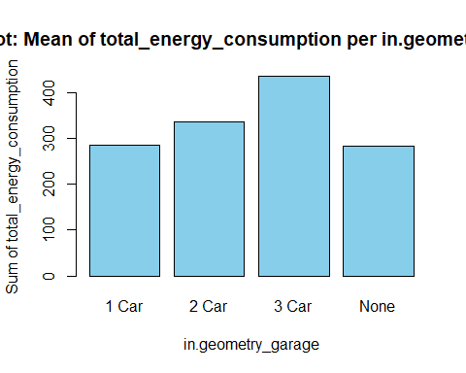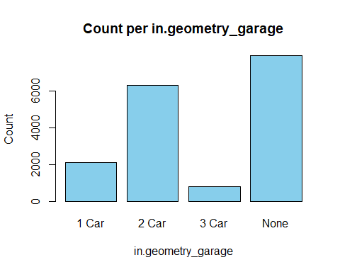

## [1] "in.geometry_wall_exterior_finish 26.3736263736264 %"

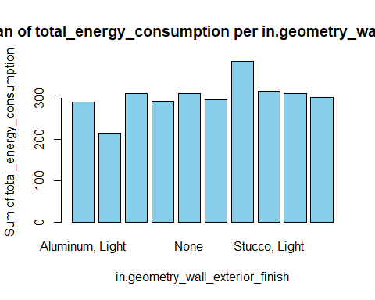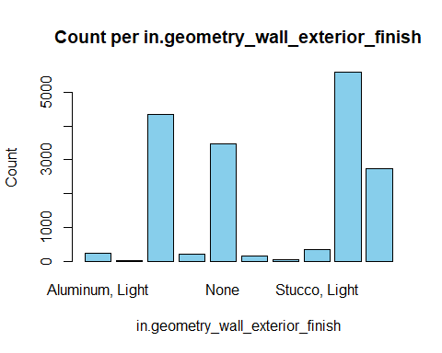

## [1] "in.geometry_wall_type 27.4725274725275 %"

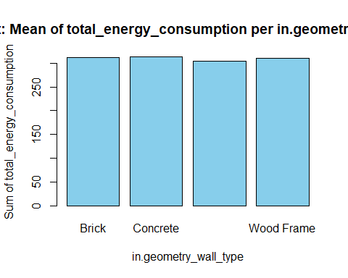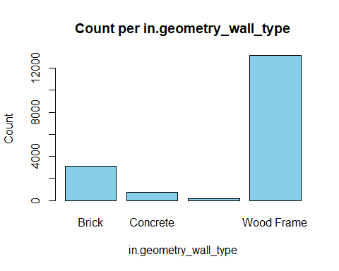

## [1] "in.has_pv 28.5714285714286 %"

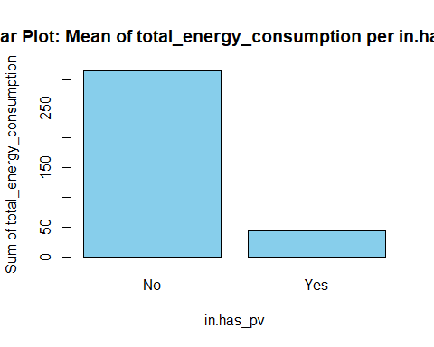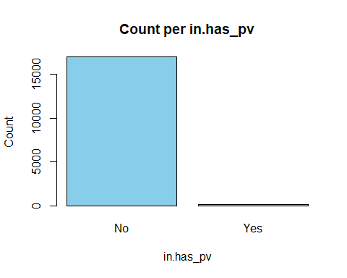

## [1] "in.heating_fuel 29.6703296703297 %"

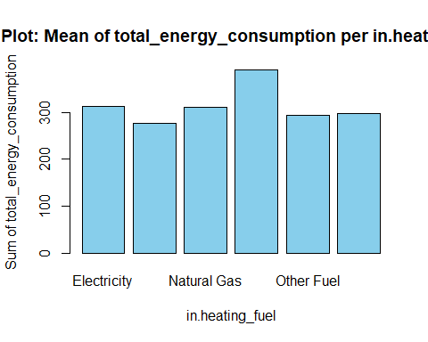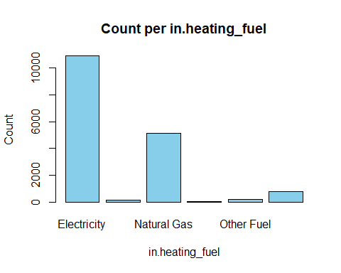

## [1] "in.heating_setpoint_has_offset 30.7692307692308 %"

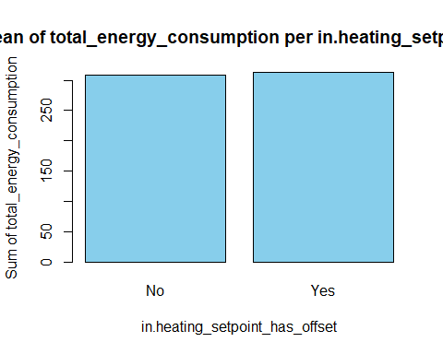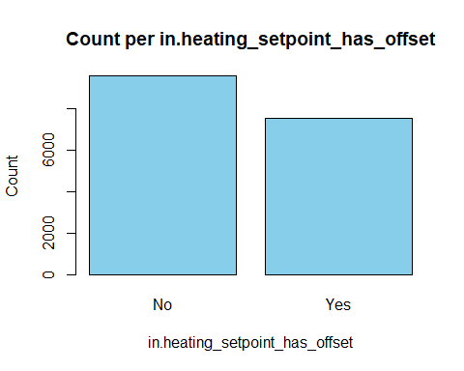

## [1] "in.heating_setpoint_offset_magnitude 31.8681318681319 %"

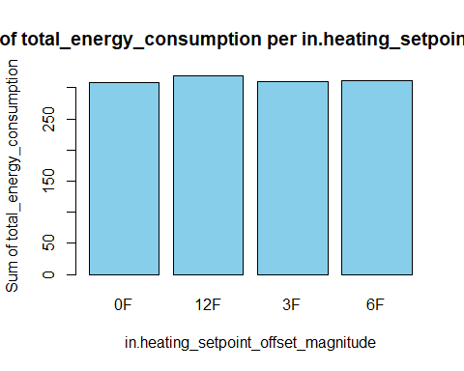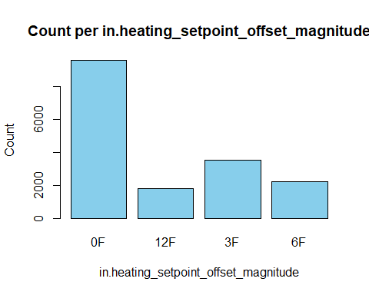

## [1] "in.heating_setpoint_offset_period 32.967032967033 %"

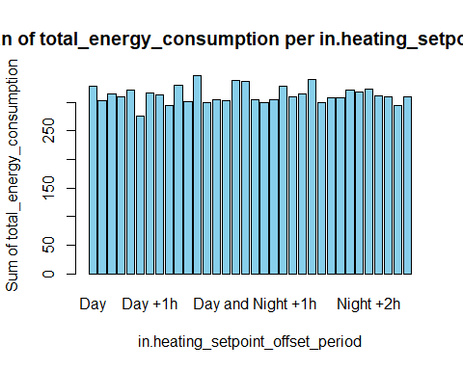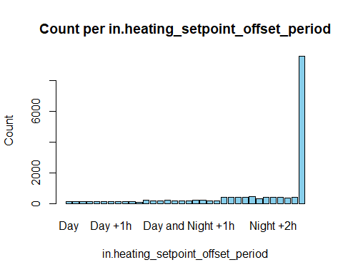

## [1] "in.hot_water_fixtures 34.0659340659341 %"

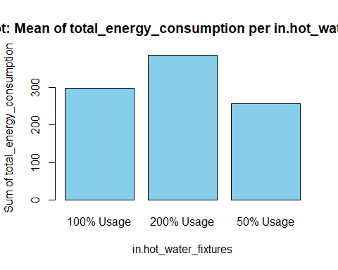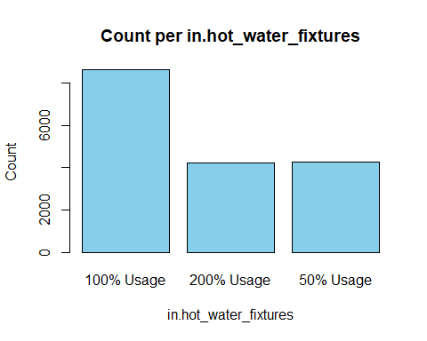

## [1] "in.hvac_cooling_efficiency 35.1648351648352 %"

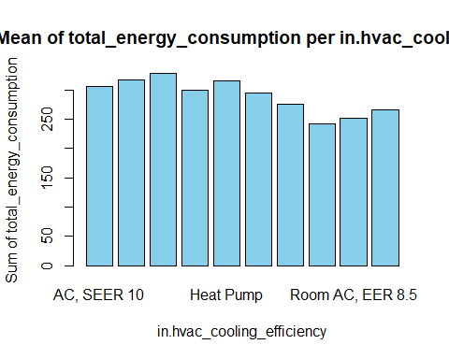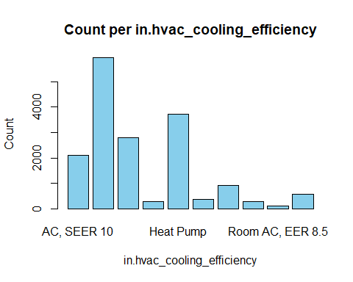

## [1] "in.hvac_cooling_partial_space_conditioning 36.2637362637363 %"

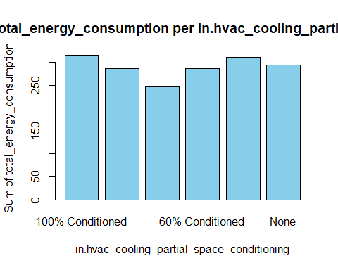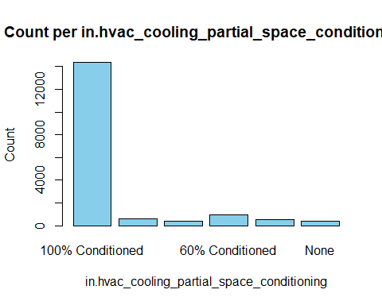

## [1] "in.hvac_cooling_type 37.3626373626374 %"

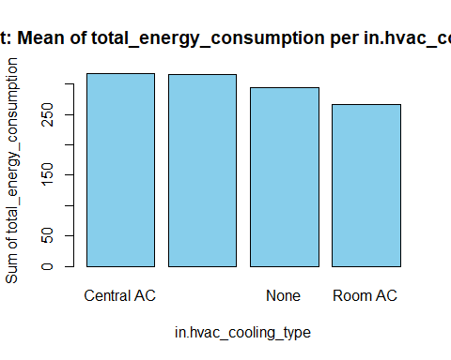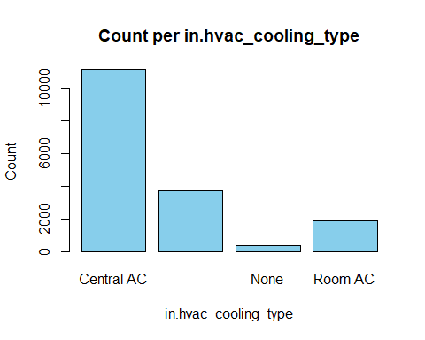

## [1] "in.hvac_has_ducts 38.4615384615385 %"

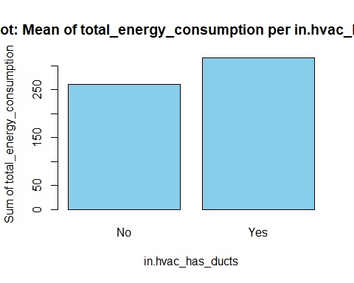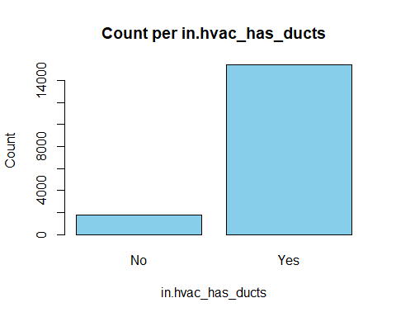

## [1] "in.hvac_has_zonal_electric_heating 39.5604395604396 %"

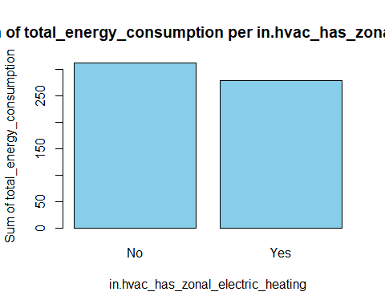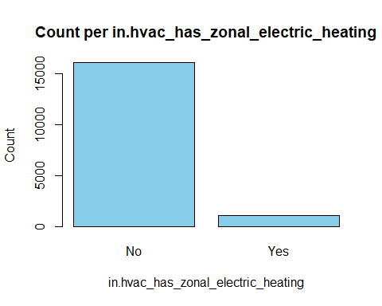

## [1] "in.hvac_heating_efficiency 40.6593406593407 %"

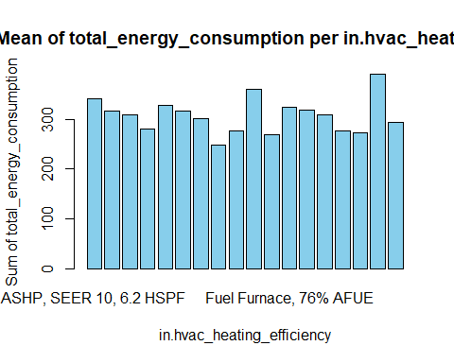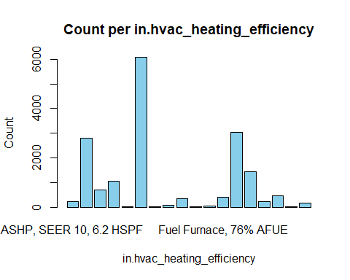

## [1] "in.hvac_heating_type 41.7582417582418 %"

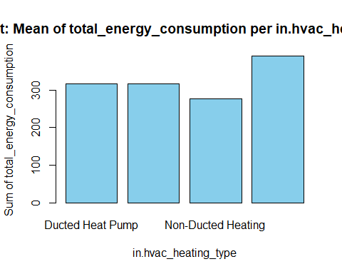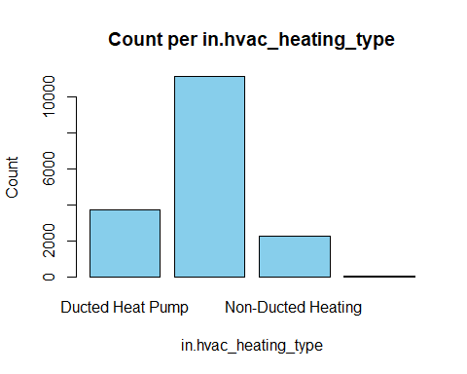

## [1] "in.hvac_heating_type_and_fuel 42.8571428571429 %"

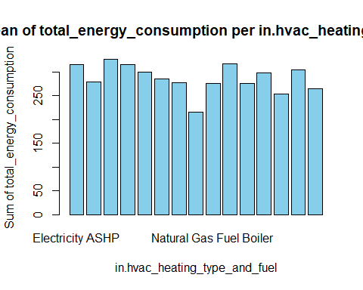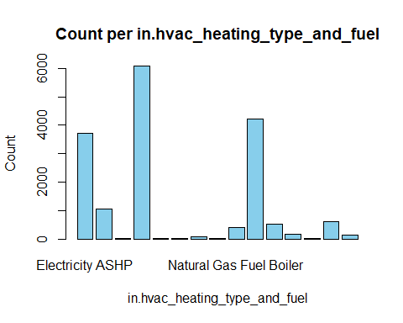

## [1] "in.income 43.956043956044 %"

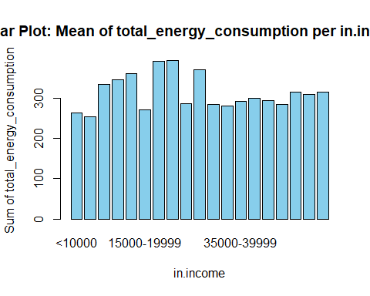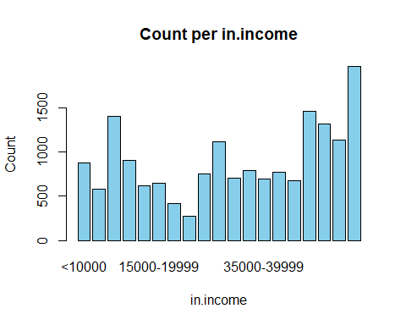

## [1] "in.infiltration 45.0549450549451 %"

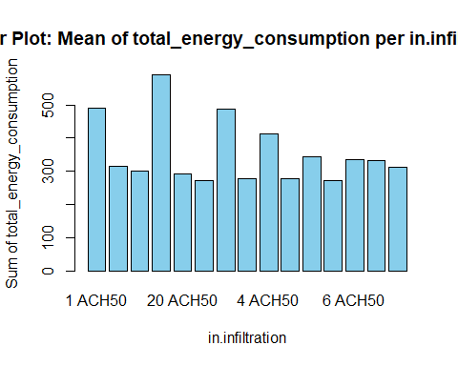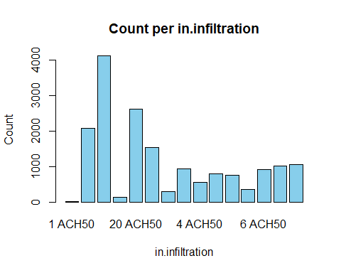

## [1] "in.insulation_ceiling 46.1538461538462 %"

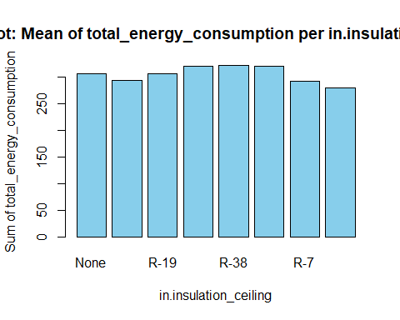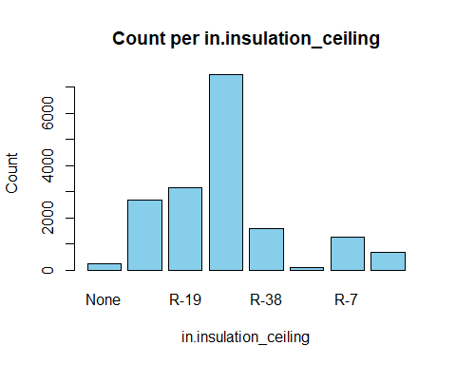

## [1] "in.insulation_floor 47.2527472527472 %"

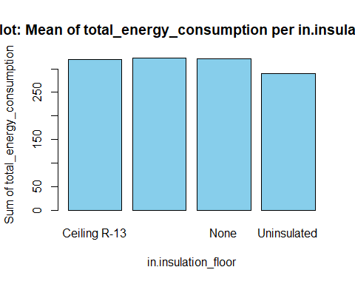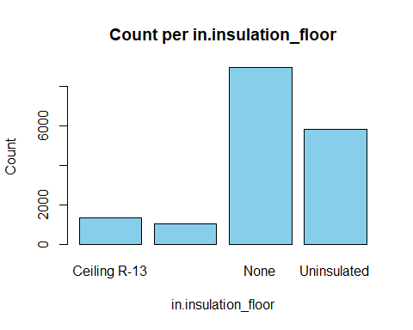

## [1] "in.insulation_foundation_wall 48.3516483516484 %"

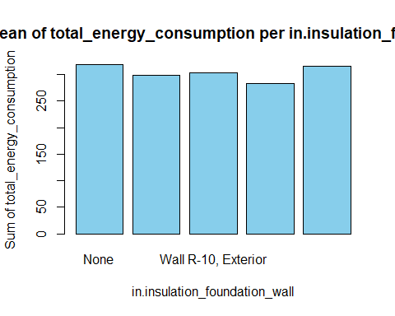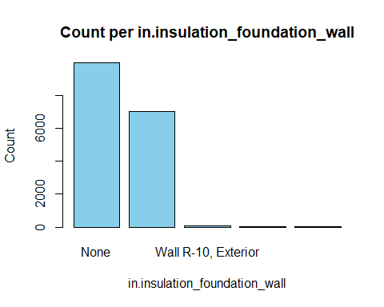

## [1] "in.insulation_rim_joist 49.4505494505495 %"

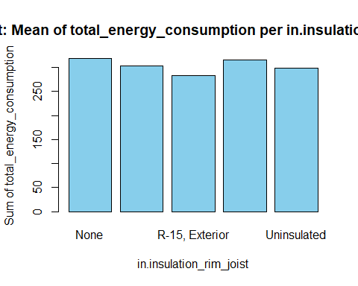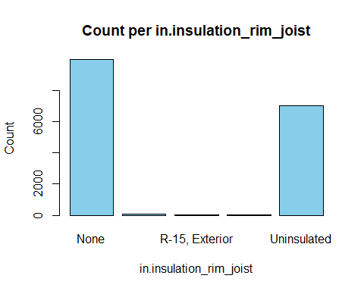

## [1] "in.insulation_roof 50.5494505494505 %"

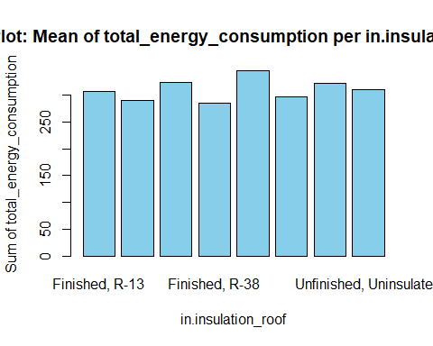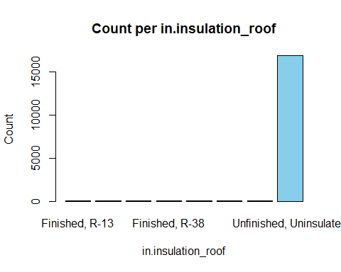

## [1] "in.insulation_slab 51.6483516483517 %"

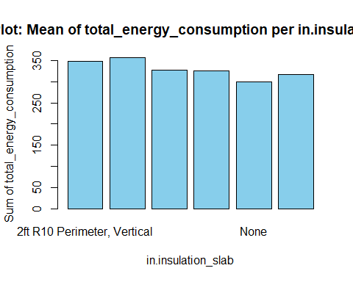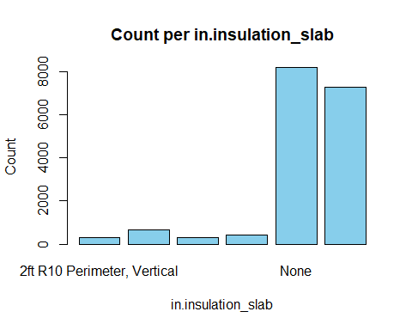

## [1] "in.insulation_wall 52.7472527472528 %"

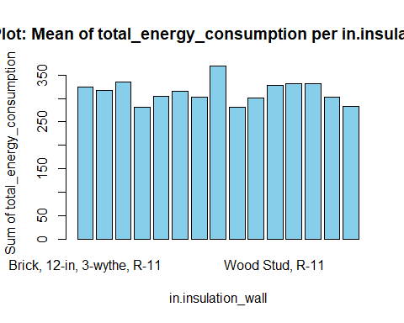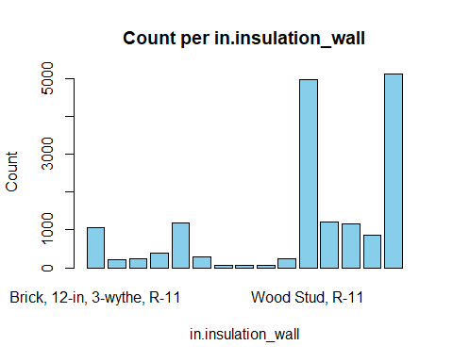

## [1] "in.interior_shading 53.8461538461538 %"

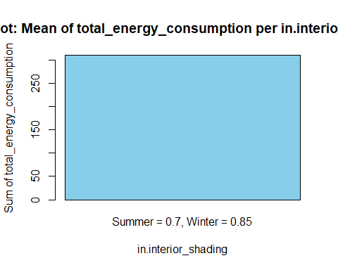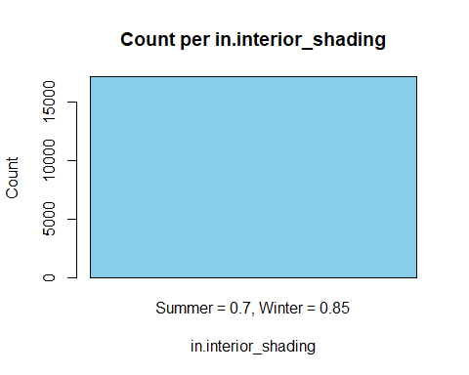

## [1] "in.misc_extra_refrigerator 54.9450549450549 %"

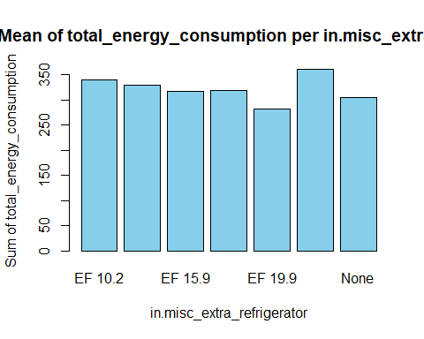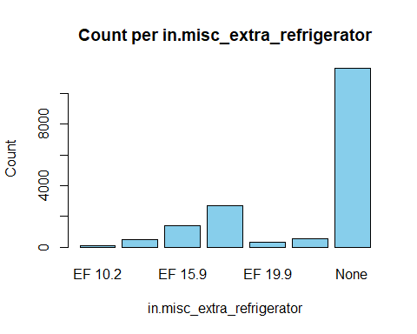

## [1] "in.misc_freezer 56.043956043956 %"

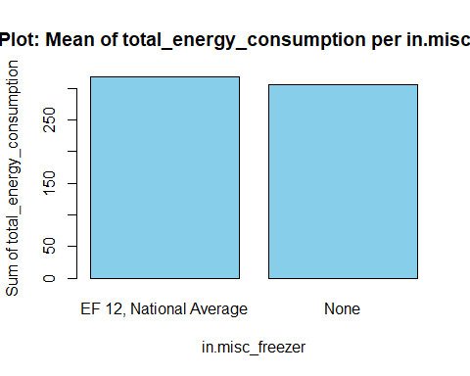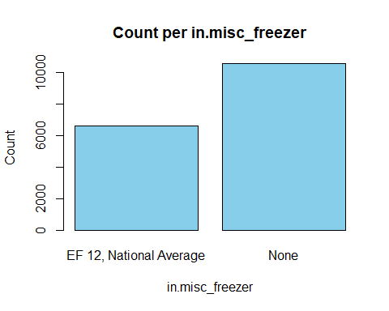

## [1] "in.misc_gas_fireplace 57.1428571428571 %"

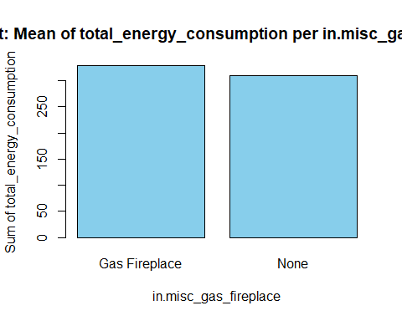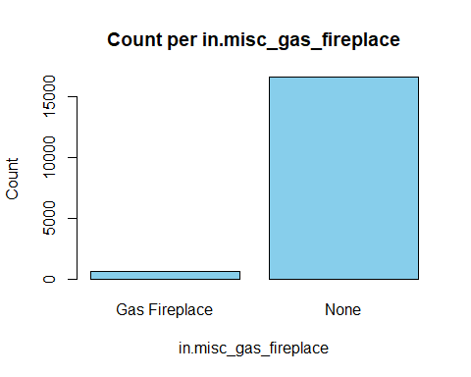

## [1] "in.misc_gas_grill 58.2417582417582 %"

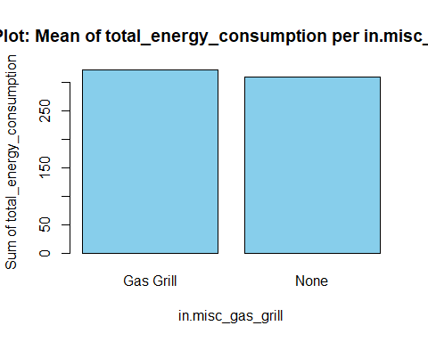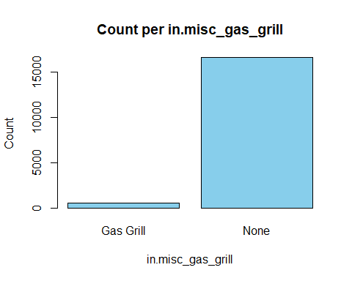

## [1] "in.misc_gas_lighting 59.3406593406593 %"

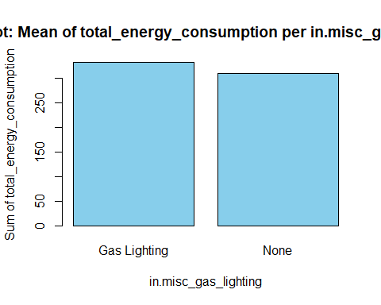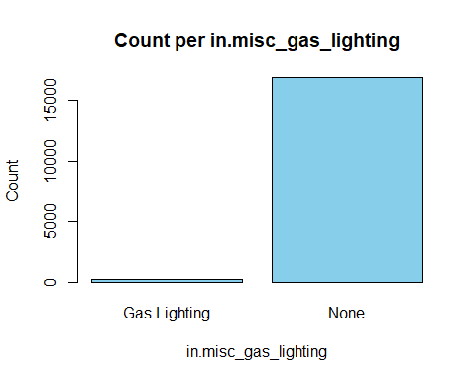

## [1] "in.misc_hot_tub_spa 60.4395604395604 %"

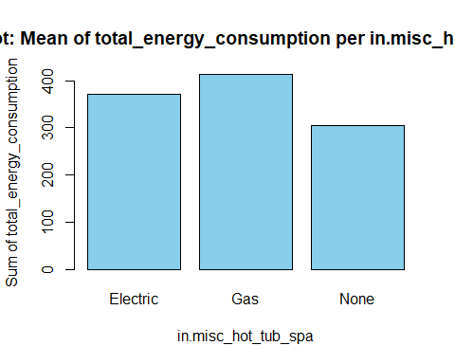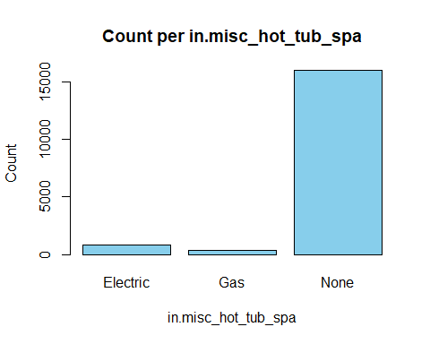

## [1] "in.misc_pool 61.5384615384615 %"

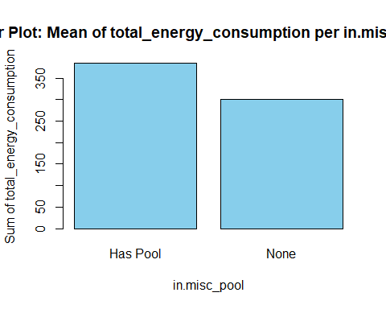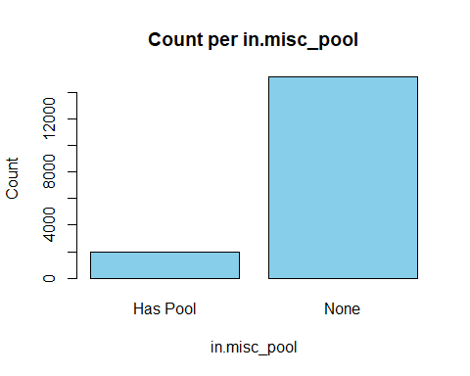

## [1] "in.misc_pool_heater 62.6373626373626 %"

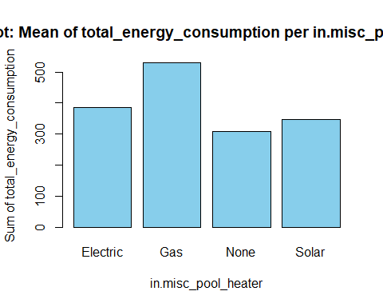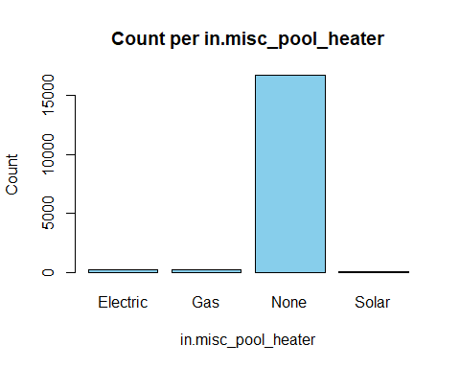

## [1] "in.misc_pool_pump 63.7362637362637 %"

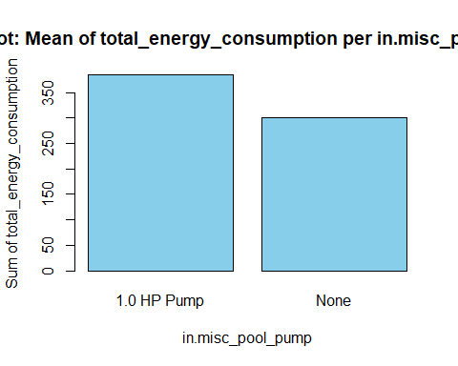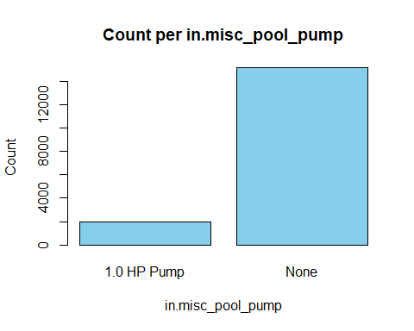

## [1] "in.misc_well_pump 64.8351648351648 %"

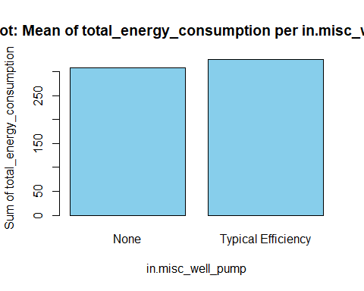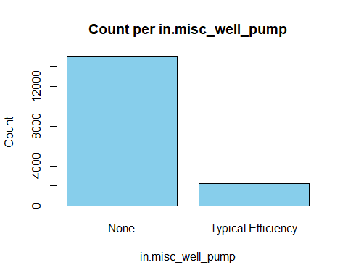

## [1] "in.natural_ventilation 65.9340659340659 %"

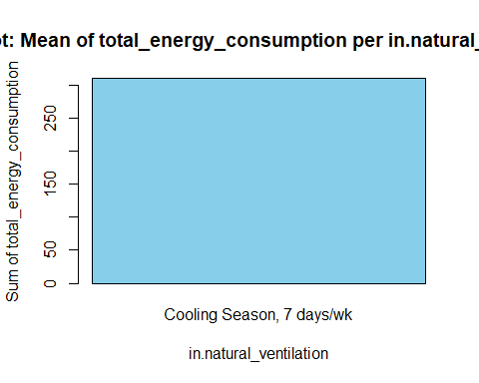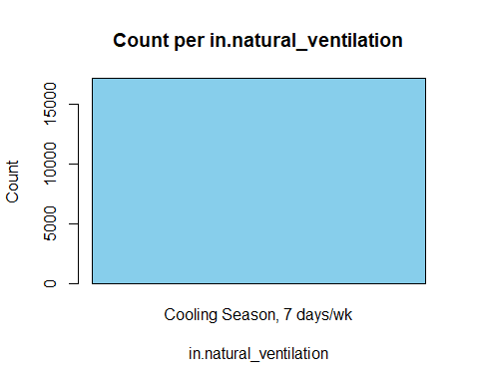

## [1] "in.neighbors 67.032967032967 %"

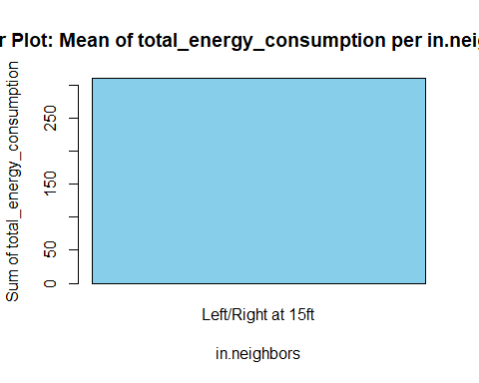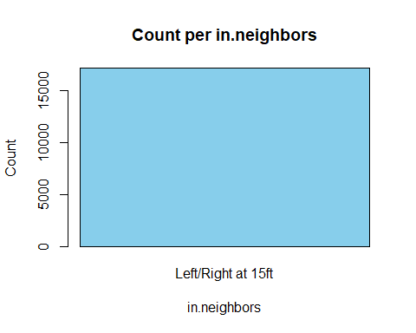

## [1] "in.occupants 68.1318681318681 %"

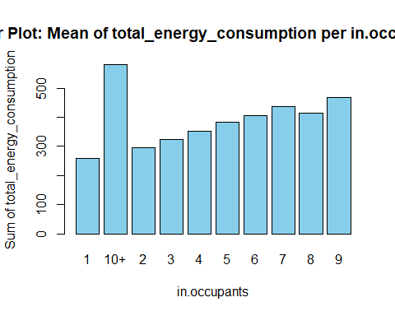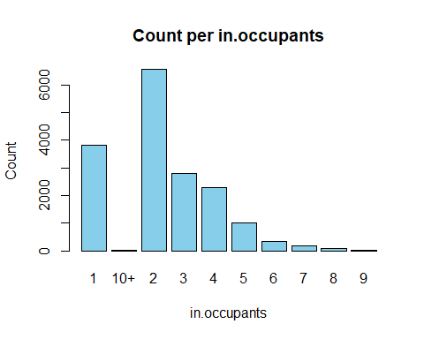

## [1] "in.orientation 69.2307692307692 %"

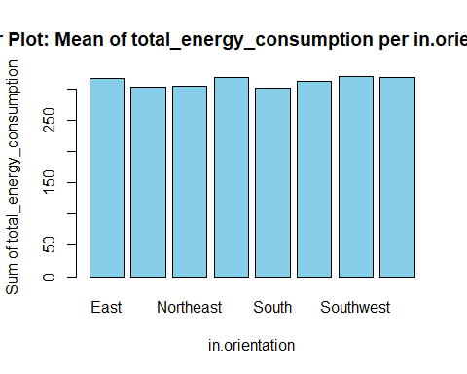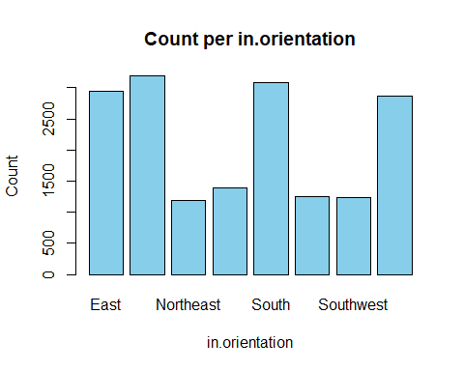

## [1] "in.plug_load_diversity 70.3296703296703 %"

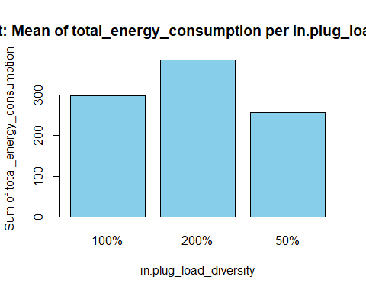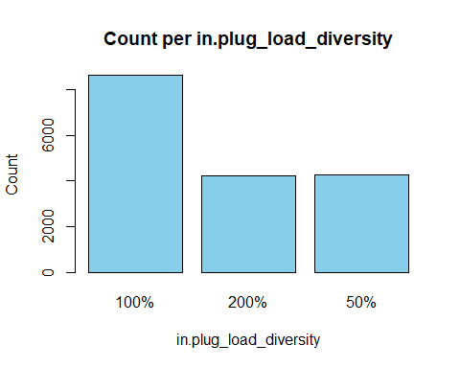

## [1] "in.pv_orientation 71.4285714285714 %"

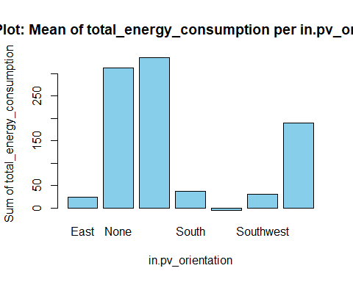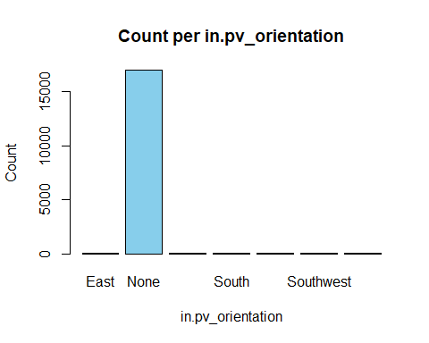

## [1] "in.pv_system_size 72.5274725274725 %"

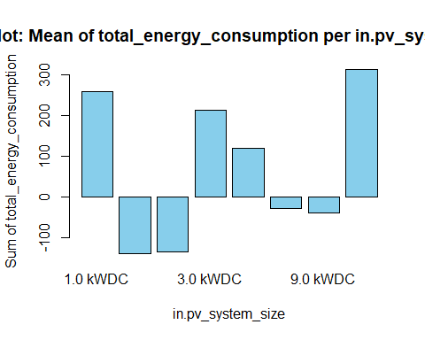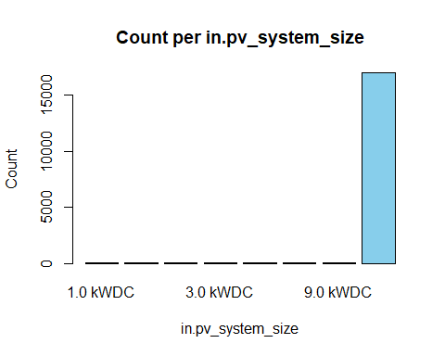

## [1] "in.refrigerator 73.6263736263736 %"

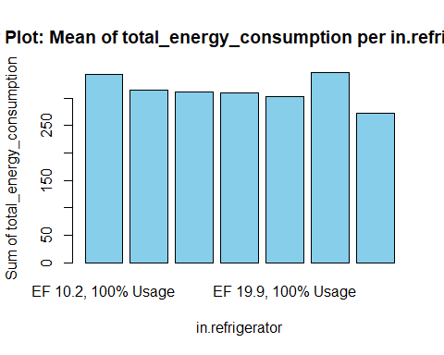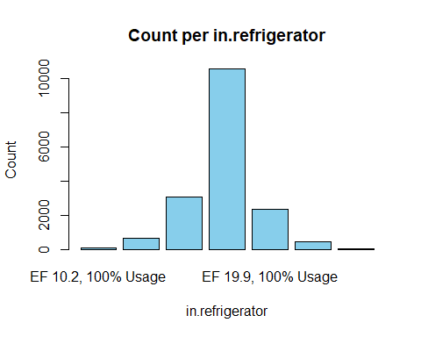

## [1] "in.roof_material 74.7252747252747 %"

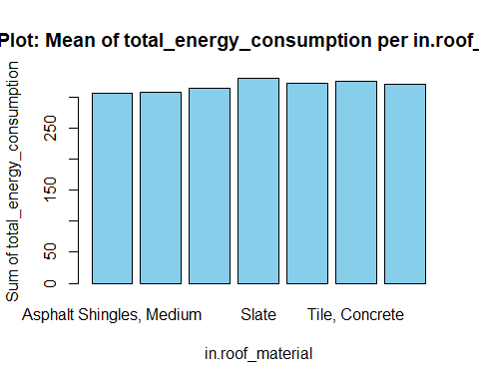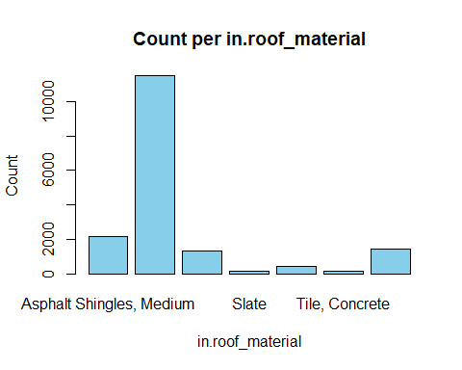

## [1] "in.tenure 75.8241758241758 %"

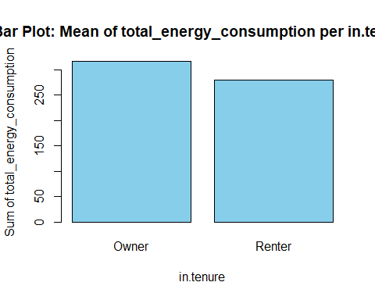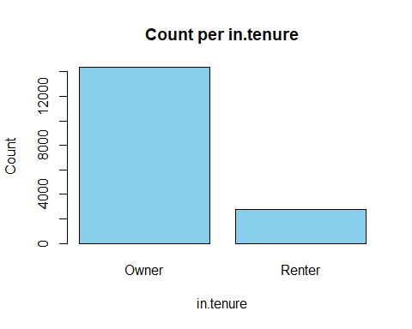

## [1] "in.usage_level 76.9230769230769 %"

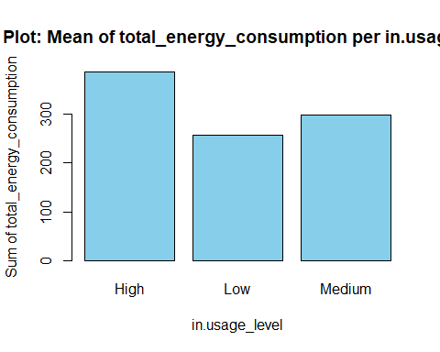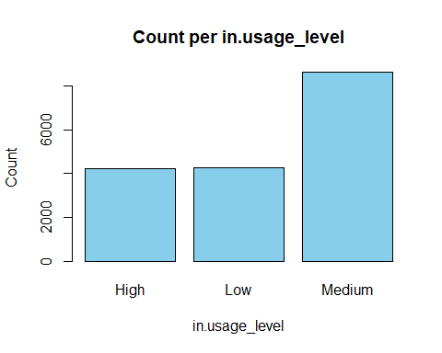

## [1] "in.vacancy_status 78.021978021978 %"

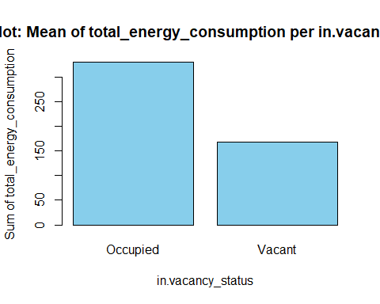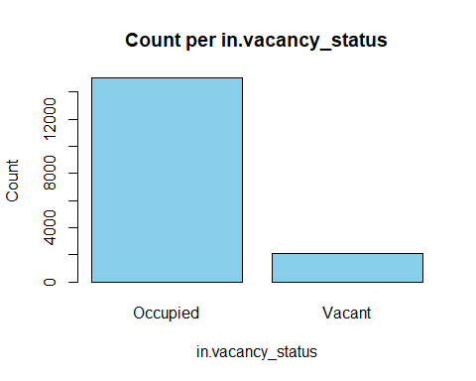

## [1] "in.vintage 79.1208791208791 %"

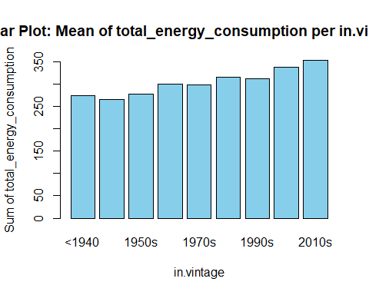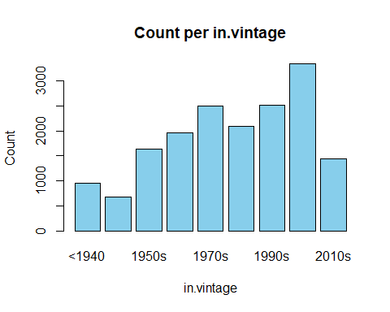

## [1] "in.vintage_acs 80.2197802197802 %"

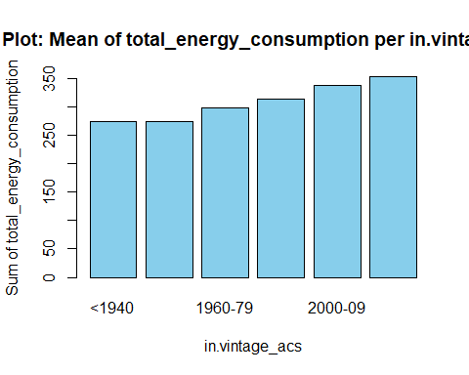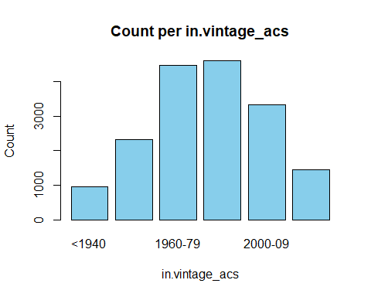

## [1] "in.water_heater_efficiency 81.3186813186813 %"

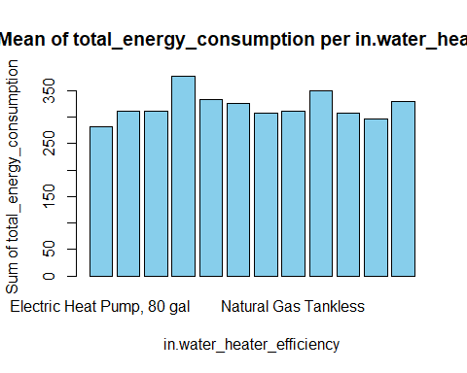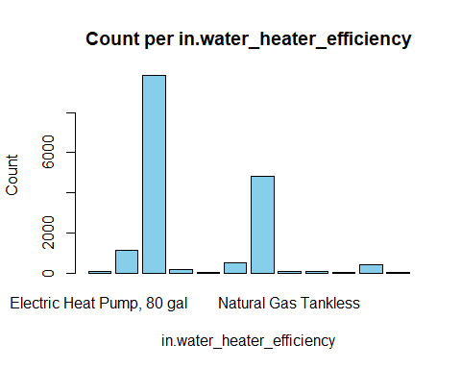

## [1] "in.water_heater_fuel 82.4175824175824 %"

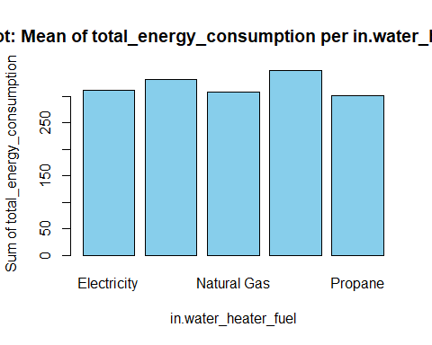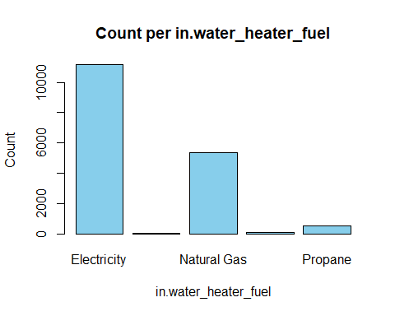

## [1] "in.window_areas 83.5164835164835 %"

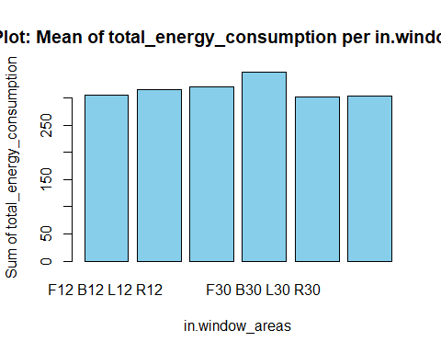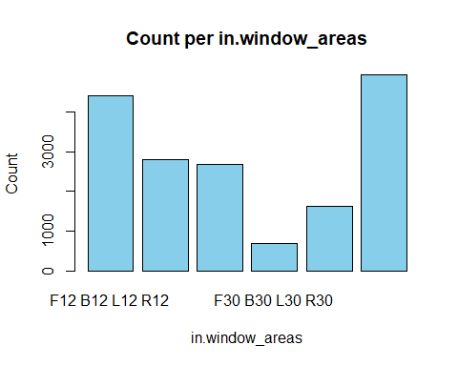

## [1] "in.windows 84.6153846153846 %"

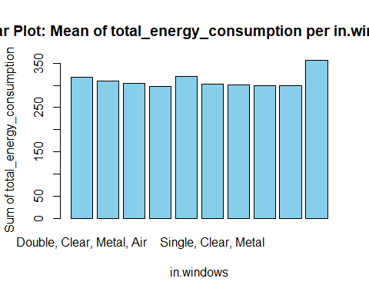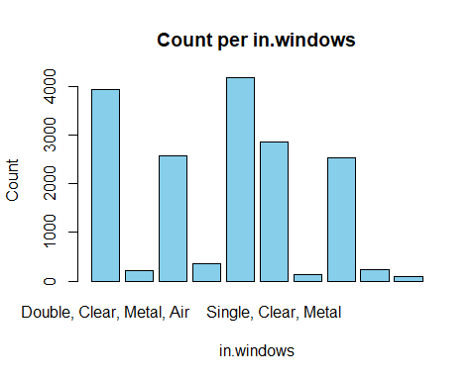

## [1] "upgrade.insulation_roof 85.7142857142857 %"

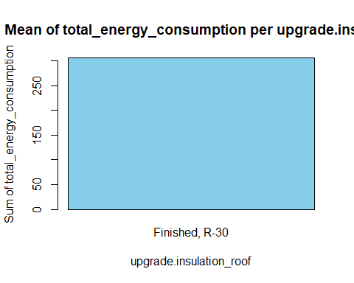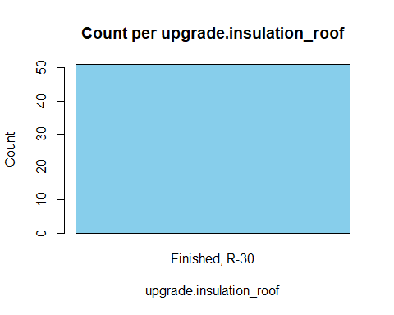

## [1] "upgrade.water_heater_efficiency 86.8131868131868 %"

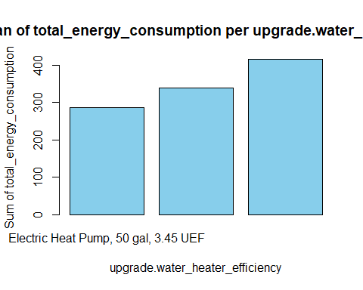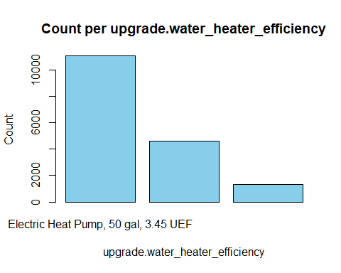

## [1] "upgrade.hvac_cooling_efficiency 87.9120879120879 %"

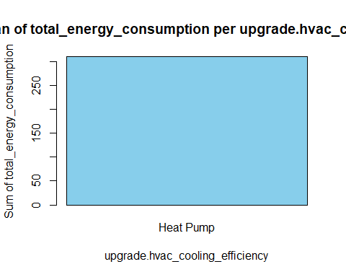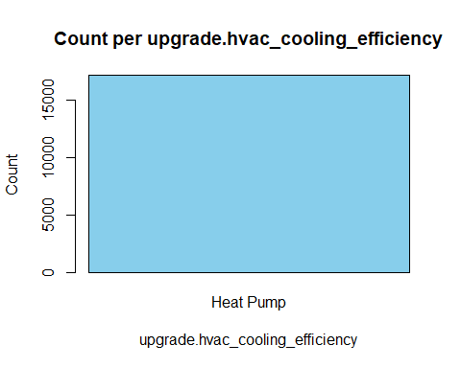

## [1] "upgrade.infiltration_reduction 89.010989010989 %"

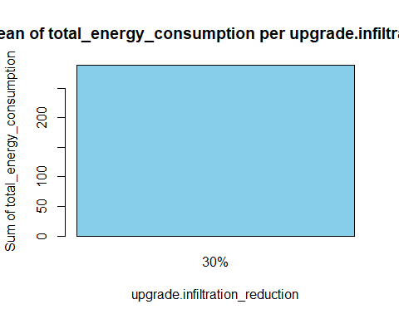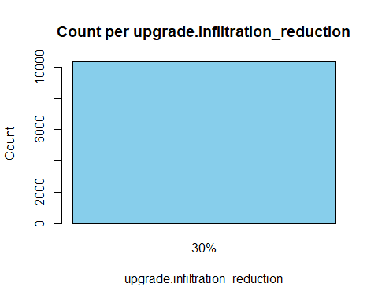

## [1] "upgrade.geometry_foundation_type 90.1098901098901 %"

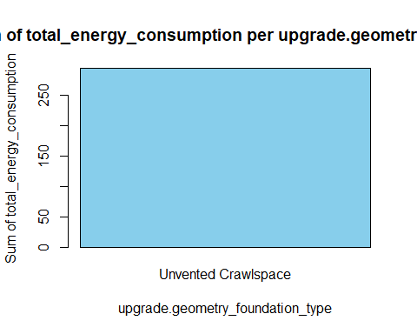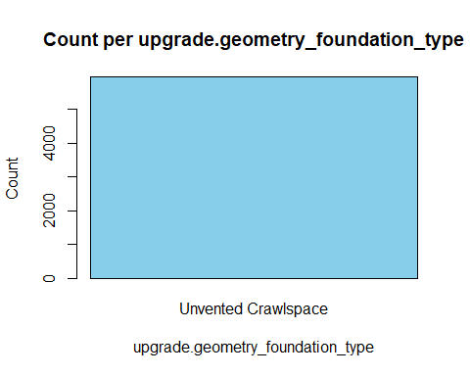

## [1] "upgrade.clothes_dryer 91.2087912087912 %"

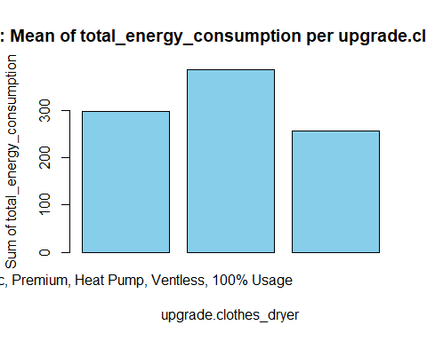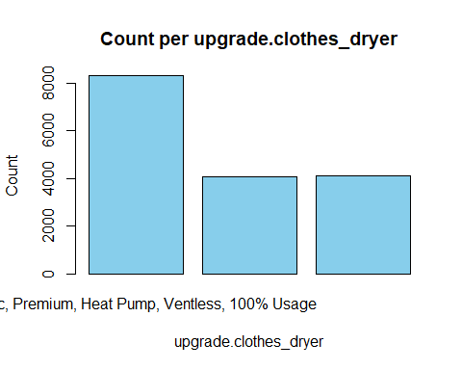

## [1] "upgrade.insulation_ceiling 92.3076923076923 %"

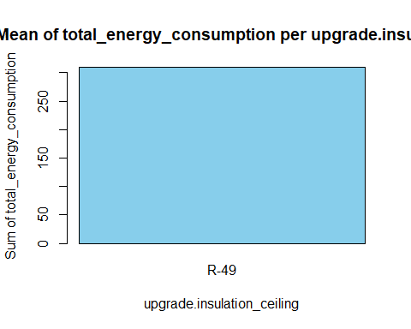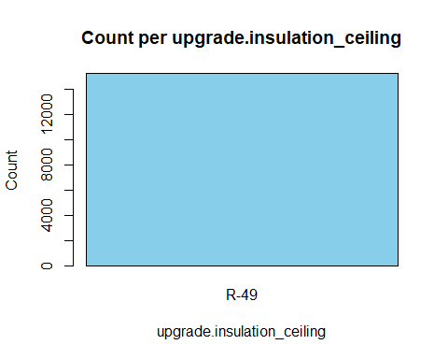

## [1] "upgrade.ducts 93.4065934065934 %"

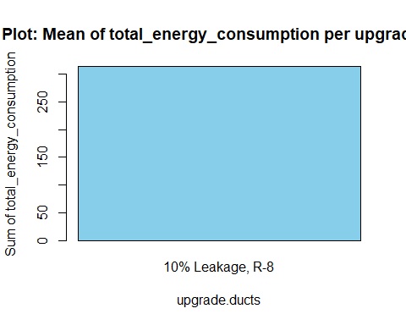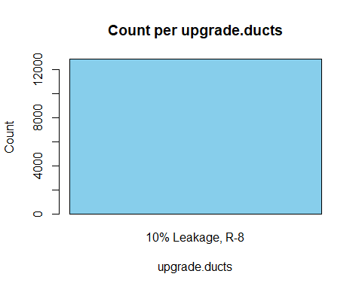

## [1] "upgrade.hvac_heating_type 94.5054945054945 %"

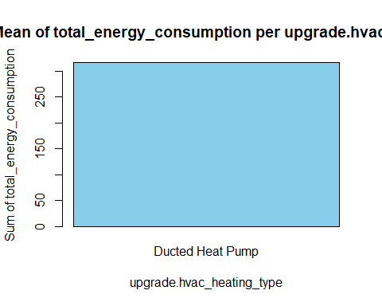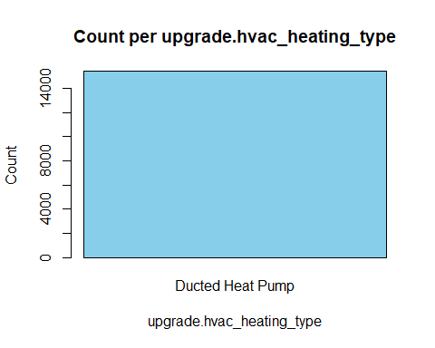

## [1] "upgrade.insulation_wall 95.6043956043956 %"

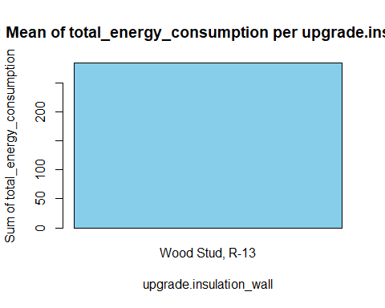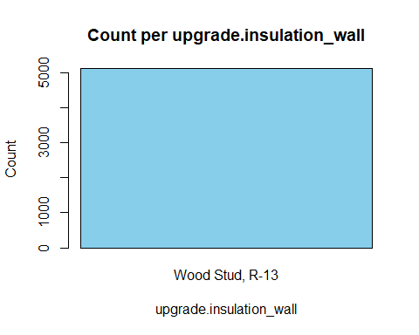

## [1] "upgrade.insulation_foundation_wall 96.7032967032967 %"

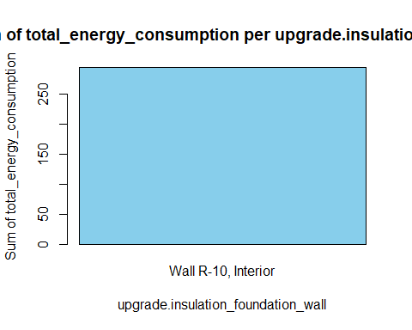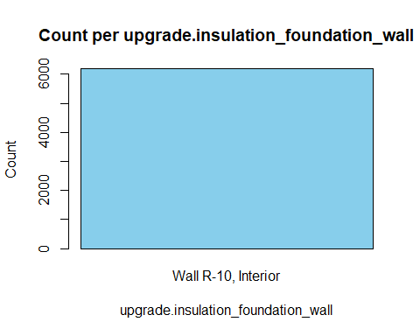

## [1] "upgrade.hvac_heating_efficiency 97.8021978021978 %"

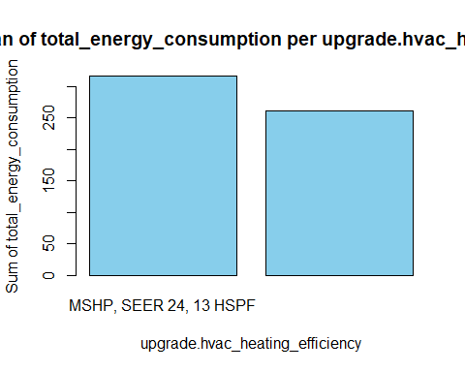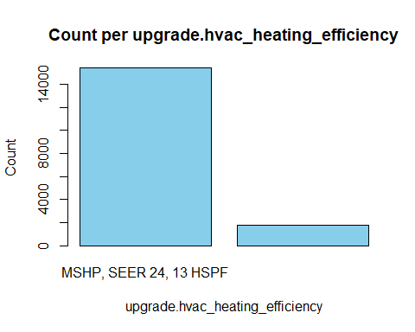

## [1] "upgrade.cooking_range 98.9010989010989 %"

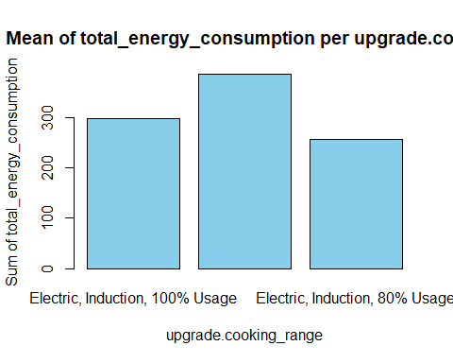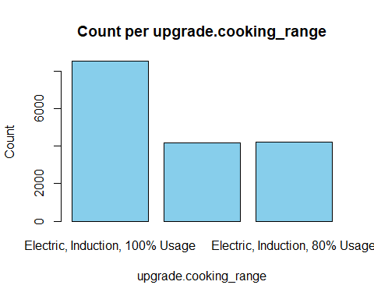

## [1] "time_of_day 100 %"

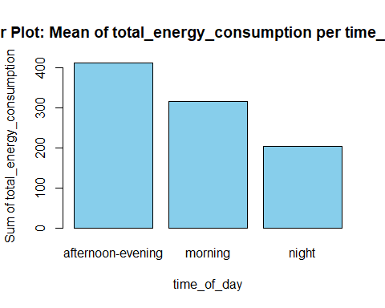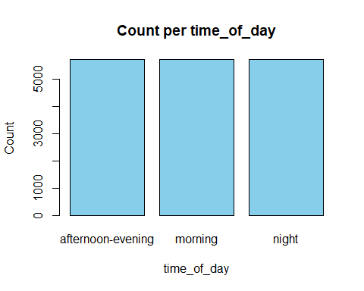

# Handling Null Values  
  
null_values_count <- sapply(filtered_data, function(x) sum(is.na(x)))  
null_values_count[null_values_count>0]

## upgrade.insulation_roof upgrade.water_heater_efficiency   
## 17079 156   
## upgrade.infiltration_reduction upgrade.geometry_foundation_type   
## 6798 11172   
## upgrade.clothes_dryer upgrade.insulation_ceiling   
## 630 1893   
## upgrade.ducts upgrade.hvac_heating_type   
## 4296 1731   
## upgrade.insulation_wall upgrade.insulation_foundation_wall   
## 12009 10947   
## upgrade.cooking_range   
## 201

# frequency_table <- table(filtered_data$in.occupants)  
# most_frequent_value <- names(frequency_table[which.max(frequency_table)])  
  
# replacing null value with the most frequent value  
filtered_data$upgrade.water_heater_efficiency[is.na(filtered_data$upgrade.water_heater_efficiency)] <- 'Electric Heat Pump, 50 gal, 3.45 UEF'  
filtered_data$upgrade.cooking_range[is.na(filtered_data$upgrade.cooking_range)] <- 'Electric, Induction, 100% Usage'  
  
filtered_data$in.occupants[is.na(filtered_data$in.occupants)] <- 1  
  
# removing columns with high null values(> 500)  
columns_to_remove <- c("upgrade.insulation_roof", "upgrade.geometry_foundation_type", "upgrade.insulation_wall", "upgrade.insulation_foundation_wall","upgrade.infiltration_reduction", "upgrade.clothes_dryer", "upgrade.insulation_ceiling", "upgrade.ducts", "upgrade.hvac_heating_type")  
  
filtered_data <- filtered_data[, !names(filtered_data) %in% columns_to_remove]

# find number of character variables  
non_numeric_cols <- sapply(filtered_data, function(x) !is.numeric(x) && !is.integer(x))  
non_num_col_names <- names(filtered_data)[non_numeric_cols] # 86 cols  
char_cols <- filtered_data[, non_num_col_names]  
  
# converting in.occupants to numeric  
filtered_data$in.occupants <- as.numeric(filtered_data$in.occupants)

## Warning: NAs introduced by coercion

# find variables with just 1 unique value  
unique_counts <- list()  
for(column_name in names(char_cols)) {  
 if(is.factor(char_cols[[column_name]]) || is.character(char_cols[[column_name]])) {  
 unique_counts[[column_name]] <- length(unique(char_cols[[column_name]]))  
 }  
}  
  
# removing variables having only 1 unique value  
columns_to_remove <- names(unique_counts[unique_counts == 1])  
filtered_data <- filtered_data[, !names(filtered_data) %in% columns_to_remove]  
  
for(column_name in names(df)) {  
 df[[column_name]] <- as.factor(df[[column_name]])  
}

# One-hot-encoding  
  
library(caret)

## Loading required package: lattice

##   
## Attaching package: 'caret'

## The following object is masked from 'package:purrr':  
##   
## lift

dummy_model <- dummyVars("~ .", data = filtered_data)  
transformed_data <- predict(dummy_model, newdata = filtered_data)  
transformed_data <- as.data.frame(transformed_data)

# Correlation Analysis  
#install.packages("ltm")  
#library(ltm)  
library(dplyr)  
#install.packages("polycor")  
library(polycor)

## Warning: package 'polycor' was built under R version 4.3.2

target <- transformed_data$total_energy_consumption  
  
# Initialize an empty vector to store correlations  
correlations <- numeric()  
  
# Initialize an empty vector to store variable names  
variable_names <- character()  
  
# Loop through columns and calculate correlations  
for (col_name in names(transformed_data)) {  
 col <- transformed_data[[col_name]]  
   
 if (is.numeric(col)) {  
 # Calculate numeric correlations (Pearson)  
 correlation <- cor(col, target, method = "pearson")  
 } else {  
 # Handle categorical variables (e.g., point-biserial correlation)  
 correlation <- point.biserial(target, col)  
 }  
   
 # Store the correlation value and variable name  
 correlations <- c(correlations, correlation)  
 variable_names <- c(variable_names, col_name)  
}  
  
# Combine correlations with variable names into a data frame  
correlations_df <- data.frame(Variable = variable_names, Correlation = correlations)  
  
# Sort correlations by absolute value in descending order  
correlations_df <- correlations_df[order(-abs(correlations_df$Correlation)),]  
  
# View(correlations_df)  
# Print the top correlated variables  
print(head(correlations_df, n = 30))

## Variable  
## 517 total_energy_consumption  
## 524 `diffuse_horizontal_radiation_[w/m2]`  
## 522 `global_horizontal_radiation_[w/m2]`  
## 518 `dry_bulb_temperature_[°c]`  
## 523 `direct_normal_radiation_[w/m2]`  
## 519 `relative_humidity_[%]`  
## 516 time_of_daynight  
## 2 in.sqft  
## 514 time_of_dayafternoon-evening  
## 520 `wind_speed_[m/s]`  
## 152 in.geometry_floor_area4000+  
## 158 in.geometry_floor_area_bin4000+  
## 456 in.vacancy_statusOccupied  
## 457 in.vacancy_statusVacant  
## 8 in.ceiling_fanStandard Efficiency, No usage  
## 234 in.hot_water_fixtures200% Usage  
## 420 in.plug_load_diversity200%  
## 453 in.usage_levelHigh  
## 512 upgrade.cooking_rangeElectric, Induction, 120% Usage  
## 26 in.clothes_dryerElectric, 120% Usage  
## 155 in.geometry_floor_area_bin0-1499  
## 3 in.bedrooms  
## 192 in.heating_setpoint  
## 521 `wind_direction_[deg]`  
## 45 in.cooking_rangeElectric, 120% Usage  
## 506 upgrade.water_heater_efficiencyElectric Heat Pump, 50 gal, 3.45 UEF  
## 54 in.cooling_setpoint  
## 36 in.clothes_washerEnergyStar, 120% Usage  
## 147 in.geometry_floor_area1000-1499  
## 508 upgrade.water_heater_efficiencyElectric Heat Pump, 80 gal, 3.45 UEF  
## Correlation  
## 517 1.0000000  
## 524 0.5060606  
## 522 0.4942252  
## 518 0.4820150  
## 523 0.4700935  
## 519 -0.4539951  
## 516 -0.4498410  
## 2 0.4438015  
## 514 0.4242852  
## 520 0.3769385  
## 152 0.3573836  
## 158 0.3573836  
## 456 0.3182012  
## 457 -0.3182012  
## 8 -0.2658037  
## 234 0.2615688  
## 420 0.2615688  
## 453 0.2615688  
## 512 0.2580684  
## 26 0.2509297  
## 155 -0.2461148  
## 3 0.2415052  
## 192 0.2310107  
## 521 0.2298198  
## 45 0.2065848  
## 506 -0.1972546  
## 54 -0.1916000  
## 36 0.1896092  
## 147 -0.1823668  
## 508 0.1785182

#write.csv(filtered_data, "C:/Users/Deep/Desktop/Sem-1 SYR/Intro to DS Lab/Project/clean_data.csv")

# List of predictor columns  
predictors <- c("`diffuse_horizontal_radiation_[w/m2]`",   
 "`global_horizontal_radiation_[w/m2]`",   
 "`dry_bulb_temperature_[°c]`",   
 "`direct_normal_radiation_[w/m2]`",   
 "`relative_humidity_[%]`",  
 "`wind_speed_[m/s]`",  
 "in.sqft",  
 "in.heating_setpoint",  
 "in.cooling_setpoint",  
 "in.bedrooms",  
 "in.heating_setpoint",  
 "in.cooling_setpoint")  
  
# Loop through each predictor and create a scatter plot  
for (predictor in predictors) {  
 plot <- ggplot(filtered_data, aes_string(x = predictor, y = "total_energy_consumption")) +  
 geom_point(aes(color = predictor), alpha = 0.6) + # Add color and set transparency  
 geom_smooth(method = "lm", se = FALSE, color = "blue") + # Add linear regression line  
 labs(title = paste("Scatter plot of Total Energy Consumption vs", predictor),  
 x = predictor,  
 y = "Total Energy Consumption") +  
 theme_minimal()  
   
 print(plot)  
}

## Warning: `aes_string()` was deprecated in ggplot2 3.0.0.  
## ℹ Please use tidy evaluation idioms with `aes()`.  
## ℹ See also `vignette("ggplot2-in-packages")` for more information.  
## This warning is displayed once every 8 hours.  
## Call `lifecycle::last_lifecycle_warnings()` to see where this warning was  
## generated.

## `geom_smooth()` using formula = 'y ~ x'

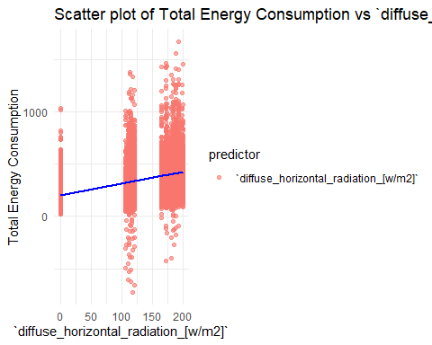

## `geom_smooth()` using formula = 'y ~ x'

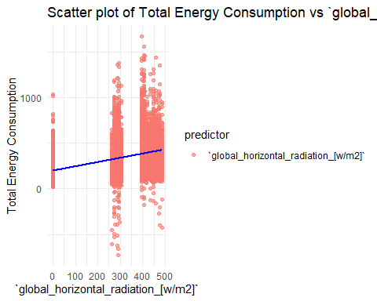

## `geom_smooth()` using formula = 'y ~ x'

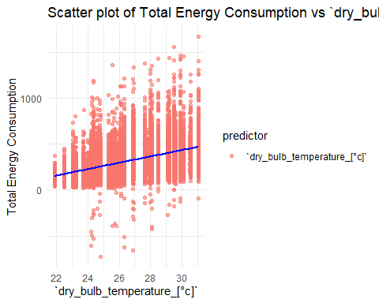

## `geom_smooth()` using formula = 'y ~ x'

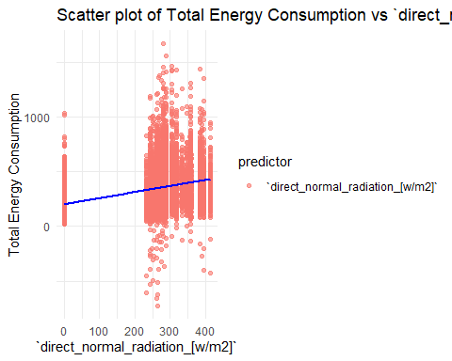

## `geom_smooth()` using formula = 'y ~ x'

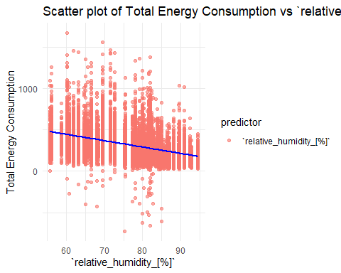

## `geom_smooth()` using formula = 'y ~ x'

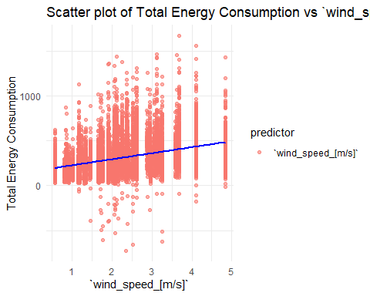

## `geom_smooth()` using formula = 'y ~ x'

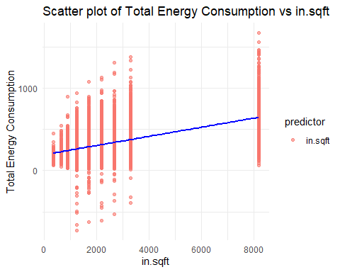

## `geom_smooth()` using formula = 'y ~ x'

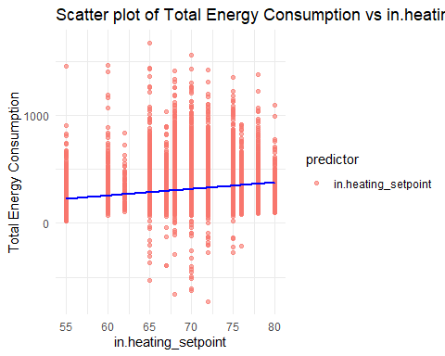

## `geom_smooth()` using formula = 'y ~ x'

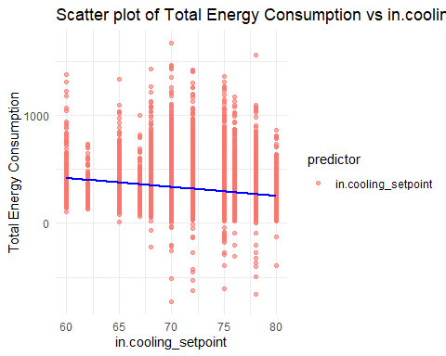

## `geom_smooth()` using formula = 'y ~ x'

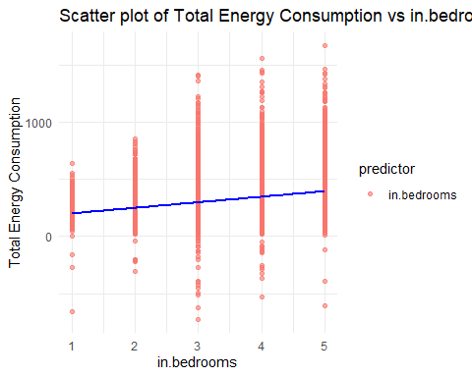

## `geom_smooth()` using formula = 'y ~ x'



## `geom_smooth()` using formula = 'y ~ x'



predictors <- c("time_of_day",  
 "in.geometry_floor_area",  
 "in.geometry_floor_area_bin",  
 "in.vacancy_status",  
 "in.ceiling_fan",  
 "in.vacancy_status",  
 "in.hot_water_fixtures",  
 "in.plug_load_diversity",  
 "in.usage_level",  
 "upgrade.cooking_range",  
 "in.clothes_dryer",  
 "in.income")  
  
for (predictor in predictors) {  
 plot <- ggplot(data, aes_string(x = predictor, y = "total_energy_consumption", fill = predictor)) +  
 geom_boxplot(outlier.shape = NA, varwidth = TRUE, notch = TRUE) + # Varying width and notch  
 scale_fill_viridis_d() + # Use Viridis color palette  
 labs(title = paste("Box plot of Total Energy Consumption by", predictor),  
 x = predictor,  
 y = "Total Energy Consumption") +  
 theme_minimal() +   
 theme(axis.text.x = element_text(angle = 45, hjust = 1))  
   
 print(plot)  
}

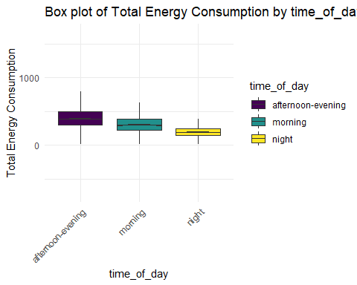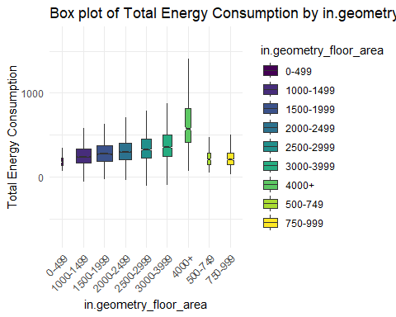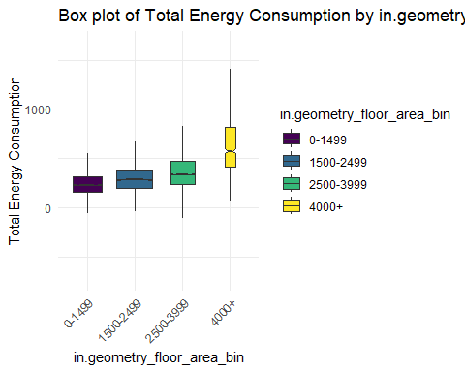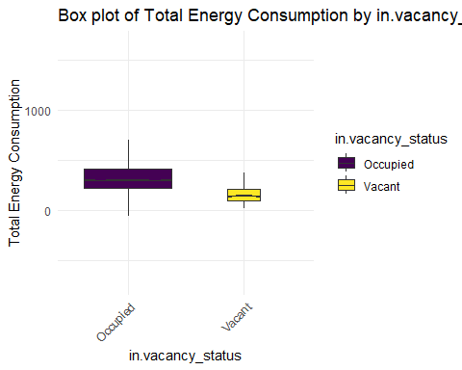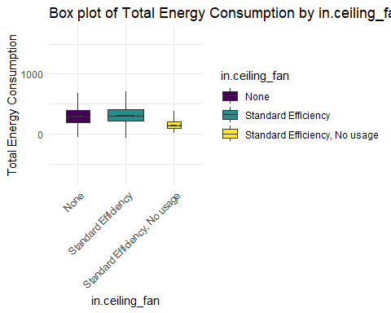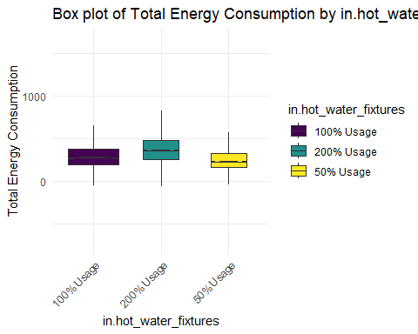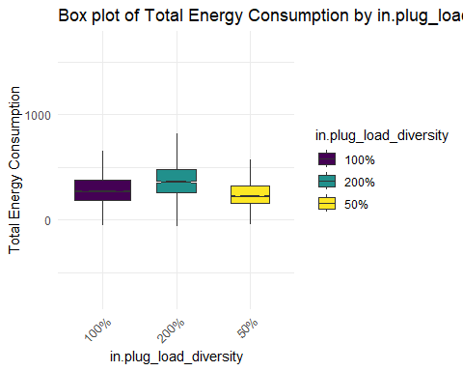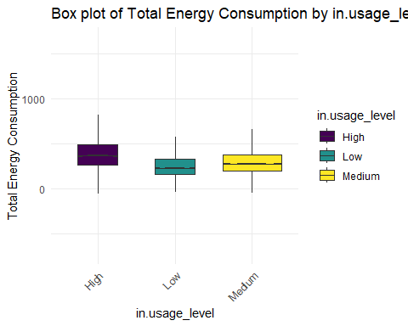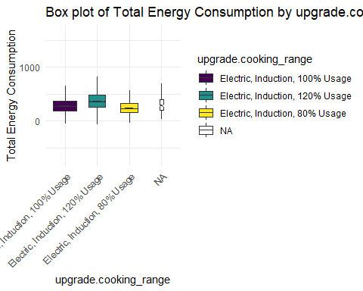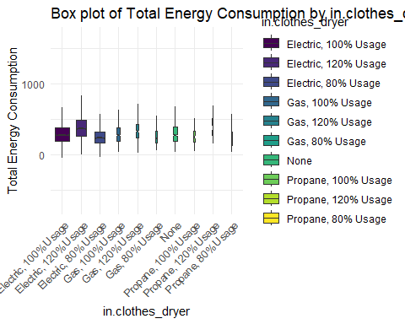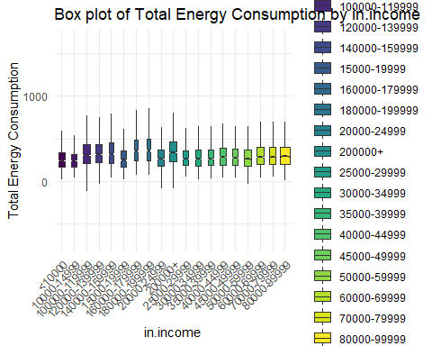

ggplot(data, aes(x = total_energy_consumption)) +  
 geom_histogram(bins = 50, fill = "blue", color = "black") +  
 labs(title = "Histogram of Total Energy Consumption",  
 x = "Total Energy Consumption",  
 y = "Frequency") +  
 theme_minimal()

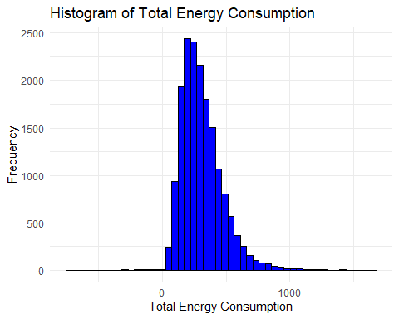

library(corrplot)

## Warning: package 'corrplot' was built under R version 4.3.2

## corrplot 0.92 loaded

continuous_variables <- c("`diffuse_horizontal_radiation_[w/m2]`",  
 "`global_horizontal_radiation_[w/m2]`",   
 "`dry_bulb_temperature_[°c]`",   
 "`direct_normal_radiation_[w/m2]`",   
 "`relative_humidity_[%]`",  
 "`wind_speed_[m/s]`",  
 "in.income")  
#   
continuous_variables <- c("diffuse_horizontal_radiation_[w/m2]",  
 "global_horizontal_radiation_[w/m2]",  
 "dry_bulb_temperature_[°c]",  
 "direct_normal_radiation_[w/m2]",  
 "relative_humidity_[%]",  
 "wind_speed_[m/s]",  
 "in.income")  
#  
continuous_data <- filtered_data[, c("total_energy_consumption",  
 continuous_variables)]  
#   
#   
# cor_matrix <- cor(continuous_data, use = "complete.obs")  
#   
# corrplot(cor_matrix, method = "color")  
#   
#   
# corrplot(cor_matrix, method = "color",  
# addCoef.col = "black", # Add correlation coefficients  
# tl.col = "black", # Color of text labels  
# tl.srt = 45, # Rotate text labels  
# cl.lim = c(-1, 1), # Set limits for color scale  
# col = colorRampPalette(c("blue", "white", "red"))(200))  
# continuous_variables <- c("`diffuse_horizontal_radiation_[w/m2]`",  
# "`global_horizontal_radiation_[w/m2]`",   
# "`dry_bulb_temperature_[°c]`",   
# "`direct_normal_radiation_[w/m2]`",   
# "`relative_humidity_[%]`",  
# "`wind_speed_[m/s]`",  
# "in.income")

ggplot(filtered_data, aes(x = time_of_day, y = total_energy_consumption)) +  
 geom_line() +  
 labs(title = "Time Series of Total Energy Consumption",  
 x = "Time",  
 y = "Total Energy Consumption") +  
 theme_minimal()

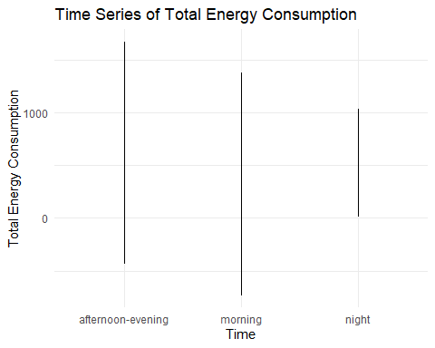

# install.packages("GGally")  
# library(GGally)  
#   
# # Select a subset of variables for the pair plot  
# selected_data <- data[, continuous_vars]  
#   
# ggpairs(continuous_vars,  
# lower = list(continuous = "points", combo = "box"), # Custom lower panel  
# upper = list(continuous = "cor", combo = "facethist"), # Custom upper panel  
# diag = list(continuous = "densityDiag"), # Custom diagonal  
# progress = FALSE) +  
# theme_light()

categorical_variables <- c("time_of_day",  
 "in.geometry_floor_area",  
 "in.geometry_floor_area_bin",  
 "in.vacancy_status",  
 "in.ceiling_fan",  
 "in.hot_water_fixtures",  
 "in.plug_load_diversity",  
 "in.usage_level",  
 "upgrade.cooking_range",  
 "in.clothes_dryer",  
 "in.income",  
 "in.bedrooms",  
 "in.heating_setpoint",  
 "in.cooling_setpoint",  
 "in.cooking_range")  
  
# Loop for bar plots with a continuous color scale  
for (cat_var in categorical_variables) {  
 # Convert the categorical variable to a numeric type for coloring  
 data[[paste0(cat_var, "_num")]] <- as.numeric(as.factor(data[[cat_var]]))  
  
 plot <- ggplot(data, aes_string(x = cat_var, y = filtered_data$total_energy_consumption, fill = paste0(cat_var, "_num"))) +  
 geom_bar(stat = "summary", fun = "mean", position = position_dodge(), color = "black") +  
 geom_errorbar(stat = "summary", fun.data = "mean_se", fun.args = list(mult = 1), position = position_dodge(0.9), width = 0.25) +  
 scale_fill_gradient(low = "blue", high = "red") + # Continuous color scale  
 labs(title = paste("Average of", "target_variable", "by", cat_var),  
 x = cat_var,  
 y = "Average target_variable") +  
 theme_minimal() +  
 theme(axis.text.x = element_text(angle = 45, hjust = 1)) # Rotate x-axis labels for readability  
  
 # Remove the temporary numeric column  
 data[[paste0(cat_var, "_num")]] <- NULL  
  
 print(plot)  
}

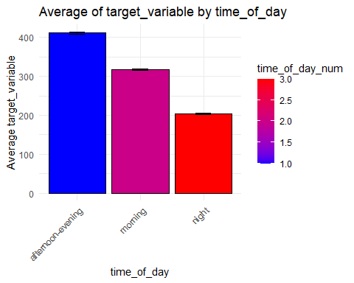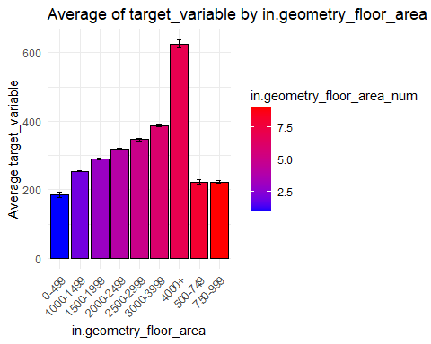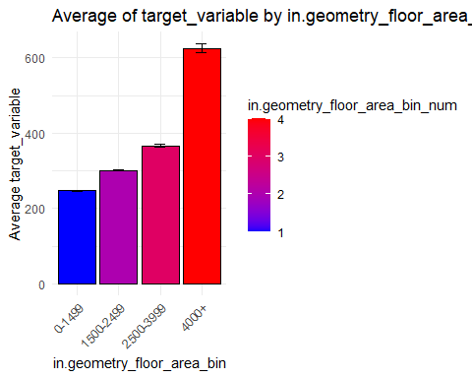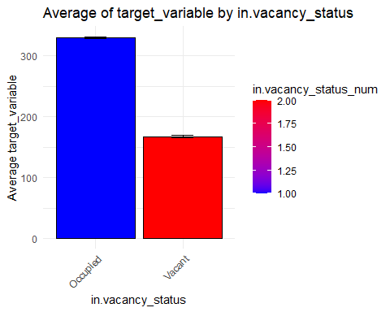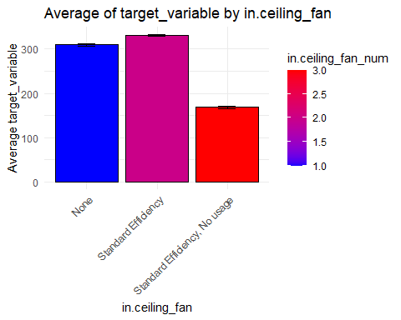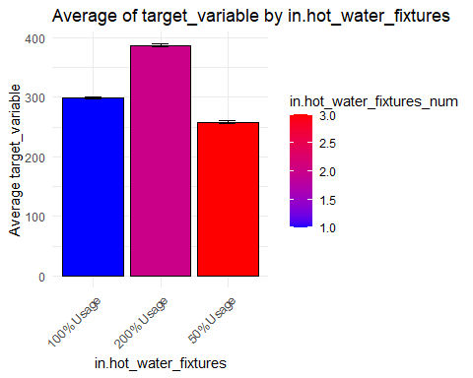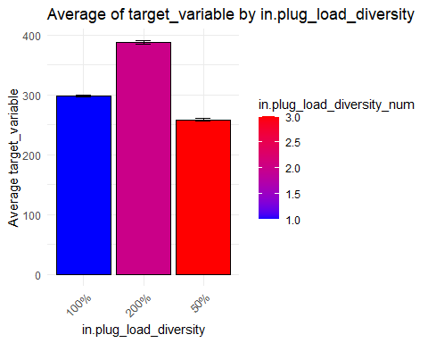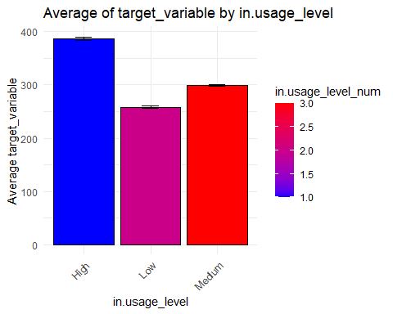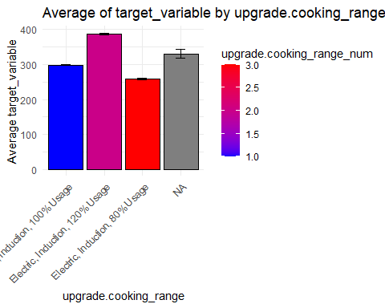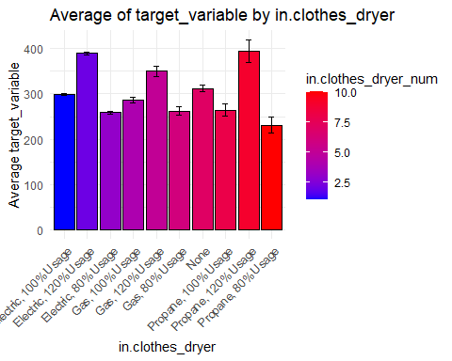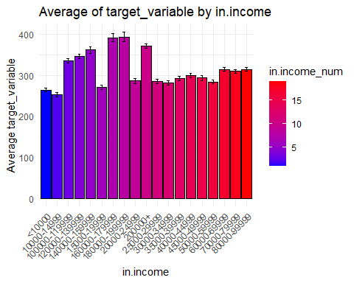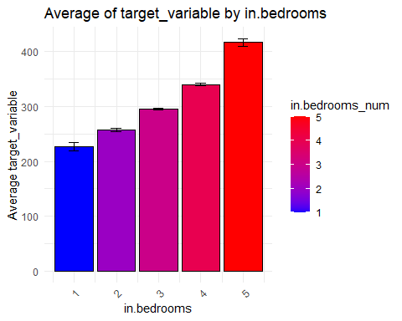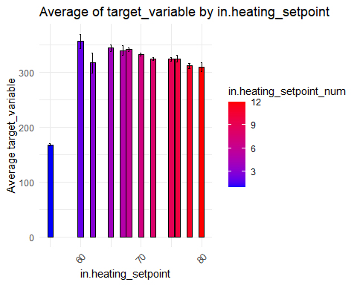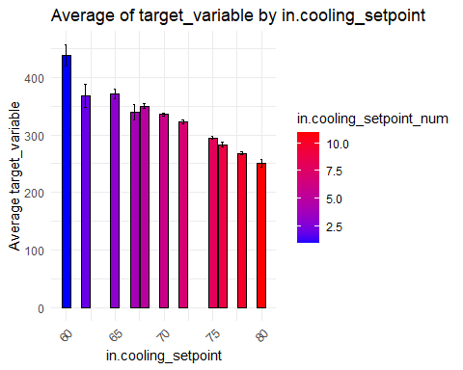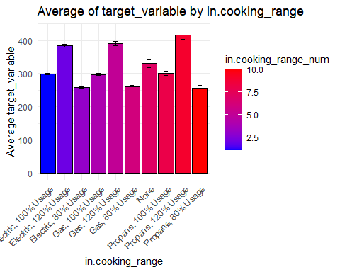

#install.packages("plotly")  
# library(plotly)  
#   
# plot_ly(filtered_data, x = ~`dry_bulb_temperature_[°c]`, y = ~total_energy_consumption, z = ~`time_of_day`,  
# type = 'scatter3d', mode = 'markers',  
# marker = list(size = 2, color = ~`time_of_day`, colorscale = 'Viridis')) %>%  
# layout(title = '3D Scatter Plot',  
# scene = list(xaxis = list(title = 'Dry Bulb Temperature [°C]'),  
# yaxis = list(title = 'Total Energy Consumption'),  
# zaxis = list(title = 'Time of Day')))  
  
continuous_variables <- c("`diffuse_horizontal_radiation_[w/m2]`",  
 "`global_horizontal_radiation_[w/m2]`",   
 "`dry_bulb_temperature_[°c]`",   
 "`direct_normal_radiation_[w/m2]`",   
 "`relative_humidity_[%]`",  
 "`wind_speed_[m/s]`",  
 "in.income")  
  
for (var in continuous_variables) {  
 plot <- ggplot(filtered_data, aes_string(x = var, y = filtered_data$total_energy_consumption, color = "time_of_day")) +  
 geom_point() +  
 labs(title = paste("Total Energy Consumption vs", var, "by Time of Day"),  
 x = var,  
 y = "Total Energy Consumption") +  
 scale_color_brewer(palette = "Set1") +  
 theme_minimal() +  
 theme(legend.position = "right")  
   
 print(plot)  
}

